Plants Unit – Week 4
Name: Hour Date:
Date Packet is due: Why late? Score:
^{Day of Week Date} If your project was late, describe why
Driving Question: How do the cells of plants create glucose to enable movement and function? How do the cells of animals reassemble the atoms in glucose with soil minerals to create molecules needed for growth and maturation?
Semester Schedule
Matter & Energy
Week 1: What happens when something burns?
Week 2: What happens to molecules during burning?
Week 3: Unit Assessment
Animals
Week 1: What are animal cells and food made from?
Week 2: What happens to food when it is consumed?
Week 3: What happens inside animal cells?
Week 4: Unit Assessment

Plants
Week 1: What are plant cells made from?
Week 2: How do plants get their food?
Week 3: What happens inside plant cells?
Week 4: Unit Assessment

Ecosystems
Week 1: How do living organisms affect each other?
Week 2: Tracing Matter
Week 3: Global Biodiversity
Week 4: Humans & Biodiversity

Anchoring Phenomenon: In this unit, we have investigated how plants (like the General Sherman) acquire mass and how they create the molecules their cells need. We will be concluding this unit by revisiting each phenomenon and revising our explanations.

Deeper Questions
- How do plants acquire mass?
- How do plants produce the molecules they need for cell energy and to gain cell mass?
- How do plants rearrange atoms in glucose and soil minerals to produce other needed molecules?

Weekly Schedule

Part 1: Introduction
- Comparative Data Dives
  - General Sherman
NGSS Standards:
HS-LS1-2. Develop and use a model to illustrate the hierarchical organization of interacting systems that provide specific functions within multicellular organisms.
HS-LS1-6. Construct and revise an explanation based on evidence for how carbon, hydrogen, and oxygen from sugar molecules may combine with other elements to form amino acids and/or other large carbon-based molecules.
HS-LS1-5. Use a model to illustrate how photosynthesis transforms light energy into stored chemical energy.
HS-LS1-7. Use a model to illustrate that cellular respiration is a chemical process whereby the bonds of food molecules and oxygen molecules are broken and the bonds in new compounds are formed resulting in a net transfer of energy.
  - van Helmont’s Tree
  - Peanut vs. Spinach Nutrition
  - Plants in Light vs. Dark

Part 2: Critiquing Responses
- Evaluating Sample Responses
- Writing a “Level 3” Response

Part 3: Investigation
- Explaining Carnivorous Plants

Part 4: Review
- Jeopardy Review Game

Part 5: Final Review
- Review of Driving Questions
- Final Q&A

Part 1: Comparative Data Dives
Directions: Analyze the data provided below. Then explain the trends in the data using the provided terms. 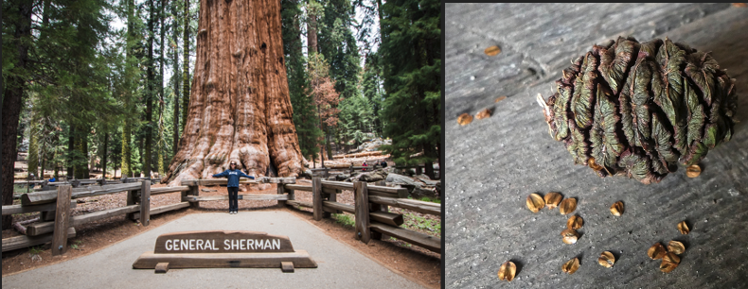
The General Sherman is the largest tree in the world. How did the General Sherman get so big? Where did the mass of this tree come from? Use the following terms in your response: glucose, photosynthesis, cellulose and biosynthesis.
Sequoia Seed
Weight: 0.005 g.

General Sherman (Sequoia Tree)
Live Weight: 5.6 million kg (12.4 million lbs.).
Dry weight: 3.1 million kg (6.8 million lbs.).

Score this response (1,2,3) - Complete: ^{Accurate:} ^{Precise:} ^{Overall:}
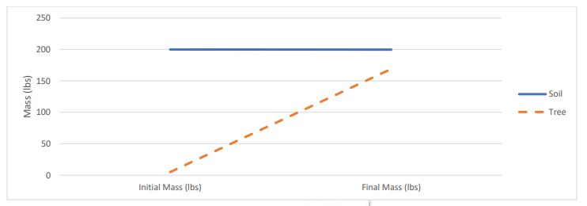
Data from van Helmont’s experiment is shown here. What does this data suggest about where the mass of a tree comes from? Use the following terms: glucose, photosynthesis, cellulose, biosynthesis, and soil minerals.

Score this response (1,2,3) - Complete: ^{Accurate:} ^{Precise:} ^{Overall:}

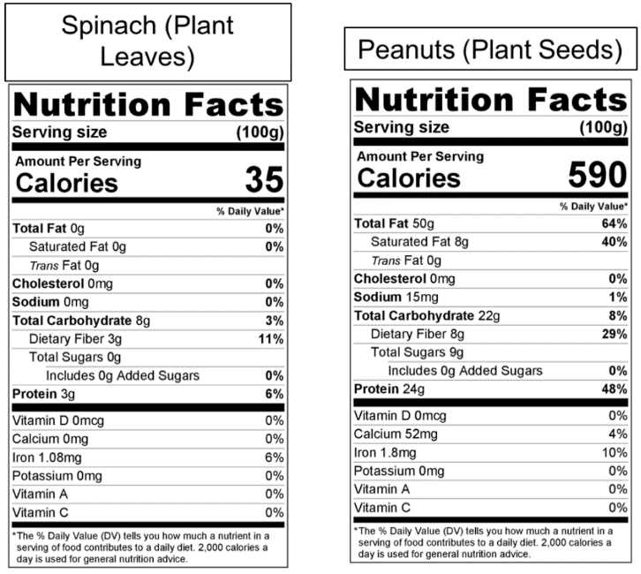
How does the carbohydrate, protein, and fat content of spinach compare to peanuts? How do you think peanuts acquire or produce such a concentrated supply of fat and protein? Use the following terms: glucose, photosynthesis, cellulose, biosynthesis, and soil minerals.
Score this response (1,2,3) - Complete: ^{Accurate:} ^{Precise:} ^{Overall:}

Data from a classroom experiment is shown below. Use this data to answer the questions below.
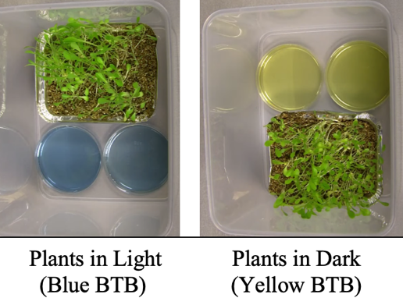
 | Blue BTB | Yellow BTB
Plants in Light | Stayed Blue | Turned Blue
Plants in Dark | Turned Yellow | Stayed Yellow
BTB Color Change | Yellow = Increased CO₂ | Blue =  Decreased CO₂

This experiment shows that in a sealed container of plants kept in sunny conditions, CO₂ levels decreased. It also shows that for plants kept in dark conditions, CO₂ levels increased. Why would these trends occur? Use the following terms: glucose, photosynthesis, cellular respiration, ATP.
Score this response (1,2,3) - Complete: ^{Accurate:} ^{Precise:} ^{Overall:}

Part 2: Critiquing Responses
Directions: Rate each of the following responses and provide a brief written justification for why you think they earned a 1 (still learning), 2 (acceptable), or 3 (sophisticated). If possible, repeat this same process with your responses on the previous page.

Q: How do plant cells acquire the matter and energy needed to function and grow?
Lucia: During photosynthesis, plants absorb light for energy. They absorb minerals from the soil in their roots.
3 2 1 Complete: Do they fully address the entire question and explain all changes to matter & energy?
3 2 1 Accurate: Is every aspect of the written response factually correct?
3 2 1 Precise: Are they effectively using terms from the course in a clear and specific manner?

Overall Score: /3 Comments:
Nina: Plants are mostly made from cellulose, which is made from glucose. Glucose is made from CO₂ and H₂O. Glucose is made during photosynthesis in the chloroplasts.

3 2 1 Complete: Do they fully address the entire question and explain all changes to matter & energy?
3 2 1 Accurate: Is every aspect of the written response factually correct?
3 2 1 Precise: Are they effectively using terms from the course in a clear and specific manner?

Overall Score: /3 Comments:
Oscar: Plants use light energy to rearrange CO₂ and H₂O molecules into glucose and O₂. Some glucose and O₂ is converted back into CO₂ and H₂O during cell respiration. Some glucose is assembled into celluose in the cell walls. Enyzmes can also rearrange atoms in glucose with soil minerals to form amino acids other molecules.
3 2 1 Complete: Do they fully address the entire question and explain all changes to matter & energy?
3 2 1 Accurate: Is every aspect of the written response is factually correct?
3 2 1 Precise: Are they effectively using terms from the course in a clear and specific manner?

Overall Score: /3 Comments:
Chandra: Plants convert light energy into the atoms they need to function and grow.
3 2 1 Complete: Do they fully address the entire question and explain all changes to matter & energy?
3 2 1 Accurate: Is every aspect of the written response factually correct?
3 2 1 Precise: Are they effectively using terms from the course in a clear and specific manner?

Overall Score: /3 Comments:

Part 3: Explaining Carnivorous Plants
Directions: Begin by watching the short video. Then read the information below before answering the subsequent questions. Video: https://www.youtube.com/watch?v=O7eQKSf0LmY
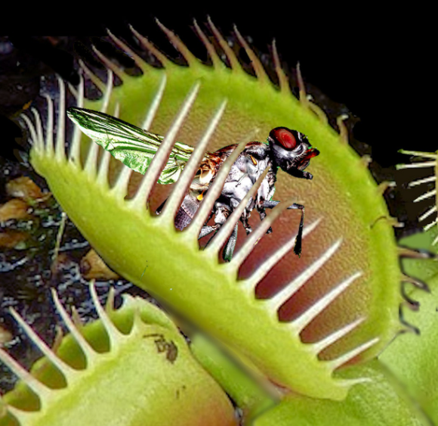
“There are over 600 known species of carnivorous plants, the majority of which thrive in bogs, marshes and rocky outcrops, or other nitrogen-poor areas where sunlight and water are abundant. These plants have evolved the ability to trap and digest insects, which are an excellent source of nitrogen as they contain around 10% nitrogen by mass. Carnivorous plants are able to obtain between 10% and 80% of their total nitrogen from insects, depending on environment and type of trap employed.”
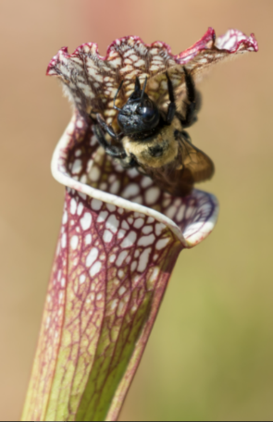
“The most famous of these prey capture mechanisms are the snap traps found in Venus flytraps and waterwheel plants. These traps consist of two lobed leaves that are able to close around insect prey when the plant senses movement of one of its trigger hairs. One of the most remarkable aspects of the snap trap is that it employs simple memory to ensure it does not close on precipitation or debris.”
“Pitcher plants are able to attract foraging, flying or crawling insects to their liquid-filled pits; once inside the pit, the insect is enzymatically digested. The lip of the pit fall trap is coated with a slippery mucous-like substance secreted by the plant; when an insect lands there, it is unable to escape … the end result is that plants are able to acquire nitrogen from trapped insects. Carnivorous plants are able to thrive in areas of extremely low nitrogen, a fact that speaks to the enormous potential of insects as a source of nitrogen.”
Source: Behie, S. W., & Bidochka, M. J. (2013). Insects as a Nitrogen Source for Plants. Insects, 4(3), 413–424. https://doi.org/10.3390/insects4030413. Image Sources: Pixabay (top) Deviant Art (bottom)
Questions: Work individually and in small groups to record your answers using scratch paper, a dry erase board, or a digital document. Be prepared to discuss your ideas as a class.
- True or false: carnivorous plants consume insects instead of photosynthesizing. Explain.
- Carnivorous plants are typically found in soils with low levels of nitrogen. How does this relate to their adapations as carnivorous plants?
- How do carnivorous plants use the insects that they trap? What cellular function (cellular respiration, photosynthesis, or biosynthesis) does this affect?
- How are enzymes used by carnivorous plants? Predict what happens to the molecules inside the insect after it is enzymatically digested using what you know about macromolecules, enzymes, polymers, and monomers.
- Explain how a carnivorous plant acquires each of the following molecules or macromolecules needed by the cell: glucose, cellulose, amino acids, proteins, fatty acids, fatty membranes.

Part 4: Jeopardy Review
Overview: In this activity, you will be playing a Jeopardy-style game to review key concepts from the course. This presentation can be accessed at https://bit.ly/WUHS-Bio-Plants-Jeopardy. The rules for this review game are posted within the presentation. You can also use this presentation outside of class to help prepare you for the unit test. Your instructor may decide to use an alternative option (like Gimkit or Kahoot).

Part 5: Review
Overview: For each objective, rank it as a 1 (completely unsure), 2 (somewhat unsure), or 3 (completely sure) based on your comfort with that objective. Afterwards, you will have time for group and whole-class review.

- How are eukaryotic organisms like plants and animals different from prokaryotic organisms?
- How are the organelles found in plant cells like those found in animal cells?
- True or false: both plant cells and animal cells have DNA. Explain.
- True or false: biosynthesis occurs in both plant cells and animal cells. Explain.
- True or false: both plant cells and animal cells have mitochondria for cellular respiration. Explain.
- True or false: both plant cells and animal cells need a constant supply of glucose and oxygen. Explain.
- True or false: only animals produce CO₂ and H₂O; plant cells produce oxygen. Explain.
- True or false: plant cells form tissues, and organs, and then systems just like animal cells. Explain.
- What are xylem and phloem? How do they relate to the function of a plant?
- True or false: most plants have a circulatory system similar to animals. Explain.
- Briefly summarize the three organelles that plant cells have that animal cells do not.
- What is photosynthesis? Where does it occur?
- How can some plants (like sequoias) grow so tall without any kind of skeletal system to support them?
- What is cellulose? What is it made from? Is it a macromolecule? Where is it found in a plant cell?
- What is photosynthesis? What molecules go into photosynthesis and what molecules are produced?
- How is energy transformed during photosynthesis?
- What are three potential purposes for the glucose that is produced during photosynthesis?
- Summarize photosynthesis in four steps.
- How is photosynthesis like “reverse combustion”?
- How does photosynthesis relate to cellular respiration?
- How does photosynthesis relate to biosynthesis?
- How do plants acquire the fat and protein they need if they don’t “eat” like animals do?
- If most of the mass of a plant comes from CO₂ and H₂O, how do plants use minerals from the soil?
- How does glucose relate to all other molecules found inside a plant cell?
- Where does biosynthesis in plant cells begin?
- Where does a plant cell acquire the atoms needed to produce molecules like fatty acids and amino acids?
- What are enzymes? How do enzymes increase the rate at which cells can form new molecules?
- True or False: enzymes provide atoms needed to assemble new molecules. Explain.
- What is the difference between monomers and polymers? How does this relate to enzymes?
- True or false: most macromolecules are polymers. Explain.
- How can enzymes combine short monomers to form one long polymer?
- How can enzymes break apart a long polymer into multiple short monomers?
- How does the enzyme Rubisco enable photosynthesis to occur?
- How do enzymes like starch synthase and fatty acid synthase change molecules?
- How does the enzyme amylase change molecules?
- How do enzymes enable animals to change the molecules in plants so that they can become a part of their own body?
- What is a decomposer? How do plants (and other species) depend on decomposers?

