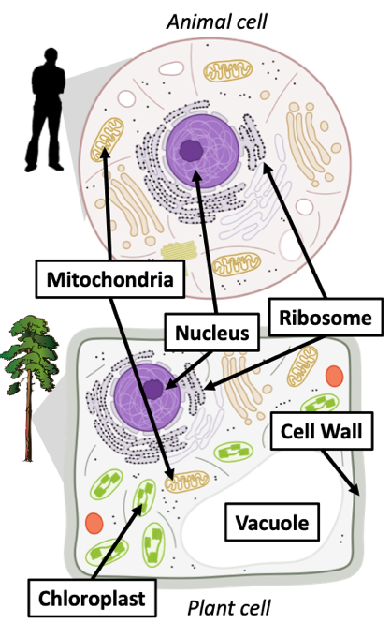
WUHS Biology: Plants Unit Storyline
Plant Cells Have Organelles. Like animals, plants are living organisms. Like the cells of animals, plant cells are eukaryotic - they contain organelles such as a nucleus, mitochondria, and ribosomes. Both plant and animal cells can recharge ATP molecules in the mitochondria when the atoms in glucose and oxygen (O₂) are rearranged to form CO₂ and H₂O during cellular respiration.
Both plant and animal cells consist of fatty membranes and protein-based structures. Like animal cells, plant cells assemble amino acids to form the proteins that do most of the work of the cell. Plant cells assemble fatty acids to form fats, including the fat-like molecules that they use to form their cell membranes.
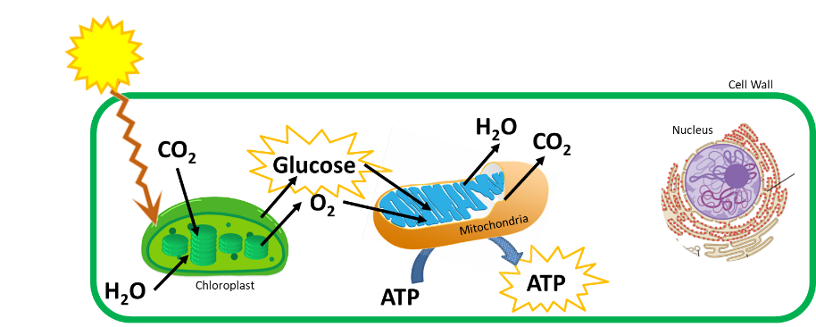
Production of Glucose. Plant cells also have organelles that animal cells do not. These include chloroplasts, cell walls, and vacuoles. Chloroplasts are the organelle where photosynthesis occurs. During photosynthesis, the atoms in CO₂ and H₂O are rearranged to form glucose and O₂. During this process, light energy is converted into the chemical energy found in the high energy bonds (C-C and C-H) of glucose.
Glucose molecules that are produced during photosynthesis can be used for multiple purposes. Most of this glucose is converted back into CO₂ and H₂O to recharge ATP during cellular respiration. Like all cells, plant cells need a continuous source of ATP or they will quickly die. As such, plants continuously rearrange the atoms in glucose and oxygen to form CO₂ and H₂O to recharge ATP on a nonstop basis.
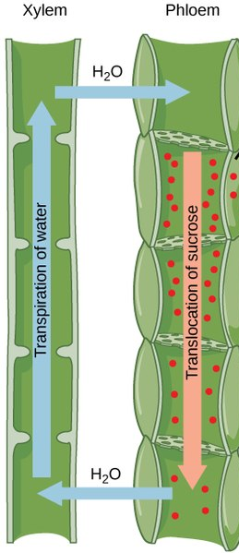
Production of Cellulose. If the plant has access to adequate amounts of light, CO_{2,} and H₂O, they will produce more glucose than is needed for cellular respiration. Some of this extra glucose can be assembled into long chains to form a strong, rigid macromolecule called cellulose. Plant cells have a thick outer ‘shell’ outside their membranes. This shell is called the cell wall and it is primarily comprised of cellulose. This is what gives plants their rigidity and shape (similar to the function of the skeletons of animals). Cellulose is what comprises most of the mass of a plant; as such, most of the atoms in plants ultimately came from CO₂ and H₂O.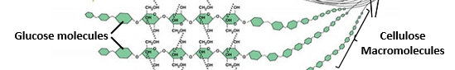
Transport Within the Plant. Some of the extra glucose will also be sent to other cells in the plant. In most cases, only the cells in the leaves can perform photosynthesis. Cells that lack access to light (such as root cells) depend on leaf cells to produce the glucose that they need for cellular respiration and other purposes. Just as animals can move substances throughout their body through the blood that flows through arteries and veins, plants have a specialized “tubes” to transport water, minerals, glucose, and all other needed substances. These “tubes” are called xylem and phloem. Xylem enables water and minerals to move up the plant (as evaporation ‘pulls’ water up the stem). Leaf cells then add glucose and other molecules to the water to form sap, which travels to all other cells through the phloem. Both xylem and phloem are vital to the function of plant cells. Xylem provides a way to transport the water needed for photosynthesis from the roots to the leaves. Phloem provides a way to transport glucose and all other molecules from the leaves to all other cells in the plant.
Making All Other Plant Molecules. Glucose molecules are the basis for creating all other molecules in the plant. Enzymes can rearrange the atoms in glucose with minerals from the soil (such as nitrogen or phosphorus) to form all other molecules found in the plant. Enzymes are specialized proteins that reduce the time and energy needed for chemical reactions to occur in the cell. Enzymes are sort of like “referees” for a chemical reaction – they make sure atoms are moved to where they need to be in order for a new molecule to be formed (but the molecular structure of the enzyme itself will stay the same).
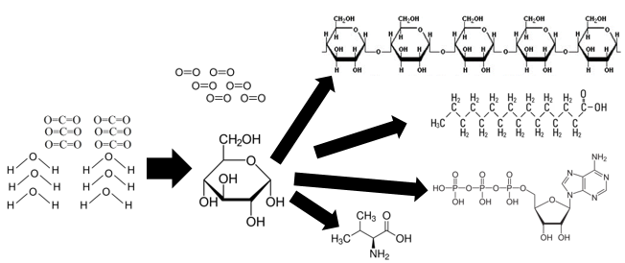
Function of Enzymes. Enzymes can assemble, disassemble, or rearrange molecules to form new molecules. One example of this is the enzyme rubisco. This enzyme rearranges the atoms in CO₂ and H₂O to form glucose. Another example includes the enzyme starch synthase. This enzyme assembles individual glucose molecules to form a carbohydrate macromolecule called starch. Plants depend on starch to ‘store’ glucose for later use (similar to how animals can store chemical energy in the high energy bonds of fat). Another enzyme, called amylase, can break down the chains of glucose in starch back into individual glucose molecules so that they can be used for cellular respiration.
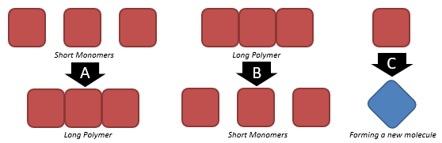
Enzymes are extremely important for the function of all living organisms. Enzymes are what assemble molecules into the macromolecules to grow and repair cells. For example, plant cells can assemble individual glucose molecules to form a long macromolecule called cellulose. In this example, glucose would be a monomer (the individual molecules) and cellulose would be a polymer (a macromolecule, or long connected chain of individual molecules). Similarly, plant cells use enzymes to rearrange the atoms from glucose and soil minerals to create amino acids. Other enzymes then assemble those amino acid monomers into the protein polymers that do the work of the cell.
From Monomers to Polymers (and vice versa). If an animal (such as a cow or sheep) consumes plant cellulose in their diet, the enzymes in their digestive tracts will break down the cellulose polymers into glucose monomers. Other enzymes will break down the protein polymers into amino acid monomers. These monomers will then travel through the blood of the animal to each cell. The cells’ enzymes will rearrange most of the glucose with oxygen to form CO₂ and H₂O to recharge their ATP. Other enzymes will assemble amino acid monomers into the protein polymers that the cell needs to function. This is how the molecules from the plant can be rearranged to form the molecules of the animal. A similar process will occur again if that animal is eaten by another animal. For example, if a human consumes a hamburger, their enzymes will disassemble the proteins into amino acids, which will be reassembled back into proteins inside the cells.
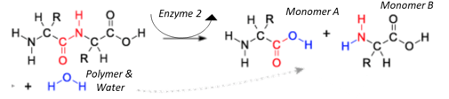
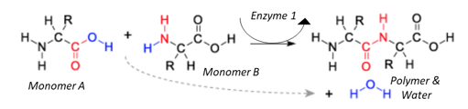
To assemble monomers (like amino acids or glucose) into polymers (like proteins or carbohydrates), enzymes will remove oxygen and hydrogen atoms from monomers to form water. The monomers will then become attracted to each other like opposite ends of a magnet. This is how individual monomers (molecules) connect to form one long polymer (macromolecule). To break up a long polymer into individual monomers, enzymes will insert water molecules. The hydrogen and oxygen atoms will reattach to the individual monomers, causing them to separate one by one from the polymer.
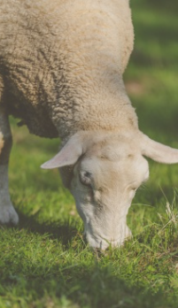
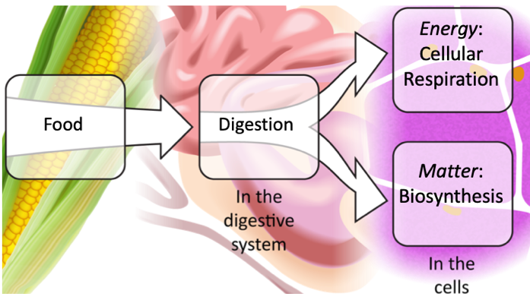
Interactions Among Living Organisms. The capacity for enzymes to assemble monomers into polymers and disassemble polymers into monomers is partly why a wide variety of species can exist on the planet. When animals consume plants, they use their enzymes to disassemble plant polymers into the individual monomers. Animal cells then use these monomers to either recharge ATP (during cellular respiration in the mitochondria) or to assemble the proteins and fats during biosynthesis.
Similarly, decomposers like mushrooms and bacteria also use enzymes to disassemble the polymers in dead or dying organisms. Unlike animals, mushrooms and other decomposers excrete enzymes to break up polymers into monomers (glucose, amino acids, and fatty acids). The decomposer will then absorb the monomers into their cells. Decomposers eventually convert most polymers into CO₂ and H₂O, which can be reabsorbed by plants to be converted back into glucose and O₂. As such, decomposers are vital for matter to continuously cycle among living organisms.
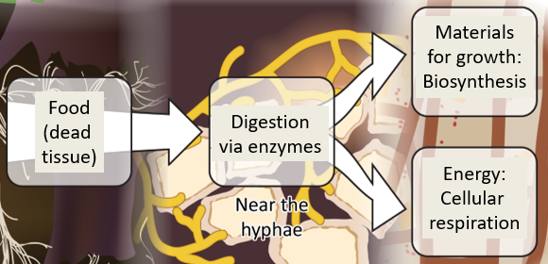
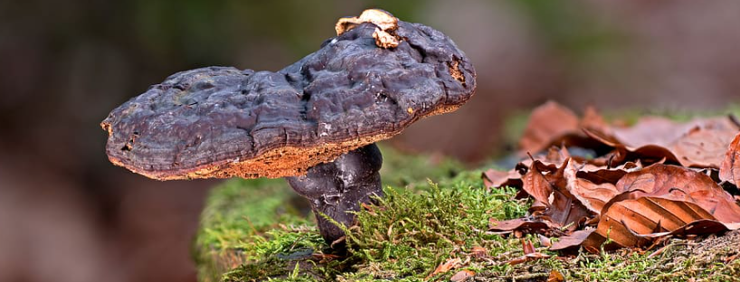
Key Points
- Plant, animal, and fungi (mushroom) cells are eukaryotic – they contain organelles such as a nucleus, mitochondria, and ribosomes. Prokaryotic organisms (like bacteria) lack organelles.
- Plant, animal, and fungi cells all have mitochondria where ATP is recharged using the high-energy bonds of molecules like glucose during cellular respiration. This results in the production of CO₂ and H₂O.
- Plant, animal, and fungi cells assemble amino acids into proteins, which perform most of the functions of cells.
- Unlike animal and fungal cells, plant cells have organelles called chloroplasts where photosynthesis occurs.
- During photosynthesis, the atoms CO₂ and H₂O are rearranged to form glucose and oxygen molecules. Light energy is converted into chemical energy found in the high energy bonds of glucose.
- The glucose that is produced in the chloroplasts can be used for several purposes, including…
  - Cellular respiration in the mitochondria of plant cells to recharge ATP.
  - Assembly into long chains to form the molecule cellulose, which is primarily found in cells walls and makes up most of the mass of a plant. Cellulose provides the plant with structure like a skeleton.
  - Transport to other cells via the phloem to be used for cellular respiration and photosynthesis.
  - Rearrangement with soil minerals to form all other molecules in the cell (such as ATP, amino acids, etc.).
- Like the arteries and veins within animals, plants have xylem and phloem to transport substances to their cells.
  - Water and minerals move up the xylem tubes as a result of evaporation of water from the leaves.
  - Leaf cells add glucose and other molecules to create sap, which travels to other cells via the phloem.
- Plants can produce all other needed molecules when enzymes rearrange the atoms in glucose with soil minerals.
- Enzymes are specialized proteins that assemble, disassemble, or rearrange the atoms in molecules to form new molecules. Enzymes reduce the time and energy needed for chemical reactions but do not contribute atoms.
  - Some enzymes, like starch synthase, assemble individual monomers into long polymers (in this case, starch synthase assembles individual glucose monomers into long starch polymers).
  - Some enzymes, like amylase, disassemble long polymers into individual monomers (in this case, amylase disassembles long starch polymers into individual glucose monomers).
  - Some enzymes, like rubisco, rearrange atoms to form entirely new molecules (in this case, rubisco rearranges the carbon from CO2 molecules with the atoms in H2O molecules to form glucose).
- Polymers consist of long connected chains of individual molecules called monomers. “Polymer” and “macromolecule” are synonymous terms for what is essentially the same idea.
  - Carbohydrate and protein macromolecules are both examples of polymers.
  - Carbohydrate polymers consist of long connected chains of individual glucose monomers.
  - Protein polymers consist of long connected chains of individual amino acid monomers.
- Enzymes use water to assemble or disassemble polymers.
  - Enzymes can remove hydrogen and oxygen atoms from monomers to form water. This causes the monomers to attach to each other like magnets.
  - Enzymes can disassemble polymers by inserting water molecules between monomers, causing them to break apart from each other one by one.
- Enzymes enable organisms to use consumed molecules for matter and energy.
  - For example, if a sheep eats grass, it will acquire carbohydrates and proteins.
  - The sheep’s digestive enzymes will break the carbohydrate polymers into glucose monomers; enzymes will also break the protein polymers into amino acid monomers.
  - After the polymers are disassembled, monomers will be absorbed into the blood and moved to the cells.
  - Most of the glucose monomers will be moved to the mitochondria for cellular respiration to recharge ATP. The atoms from glucose will be rearranged with oxygen to form CO₂ and H₂O.
  - Most of the amino acid monomers will be moved to the ribosomes to be assembled into protein polymers during biosynthesis. These proteins will become a part of the sheep’s cells.
- Decomposers use enzymes to disassemble long polymers in dead or dying organisms. Decomposers are important for converting carbon-based molecules back into CO₂ and H₂O needed for plant photosynthesis.

