Ecosystems Unit – Week 1
Name: Hour Date:
Date Packet is due: Why late? Score:
^{Day of Week Date} If your project was late, describe why
Driving Question: How do living organisms affect each other?
Semester Schedule
Matter & Energy
Week 1: What happens when something burns?
Week 2: What happens to molecules during burning?
Week 3: Unit Assessment
Animals
Week 1: What are animal cells and food made from?
Week 2: What happens to food when it is consumed?
Week 3: What happens inside animal cells?
Week 4: Unit Assessment

Plants
Week 1: What are plant cells made from?
Week 2: How do plants get their food?
Week 3: What happens inside plant cells?
Week 4: Unit Assessment

Ecosystems
Week 1: How do living organisms affect each other?
Week 2: Tracing Matter
Week 3: Global Biodiversity
Week 4: Humans & Biodiversity

Anchoring Phenomenon: This week we are investigating how living organisms interact with each other and with the non-living resources where they live. Specifically, we are wondering why the population of predators is so much smaller than the population of their prey. We’ll also consider what factors determine how many organisms can live in an area.

Deeper Questions
- How do living species interact with each other and their environment?
- What determines how many species can live in an area?
- What happens when the movement of matter and the flow of energy through living organisms becomes disrupted?

Weekly Schedule

Part 1: Introduction
- Initial Ideas – Isle Royale Videos
- Data Dive – Isle Royale Populations
- Discussion & Developing Explanations

Part 2: Core Ideas
- Core Ideas
- Revisions of Part 1 Explanations

Part 3: Investigation
- Part 3A: Fox Meadow Simulation
- Part 3B: Tabletop Ecosystems

Part 4: Review & Assessment
- Critiquing Ideas
- Assessment

Part 5: Life Connections
- Weekly Recap
- Life Connections – 3 Burritos
NGSS Standards: HS-LS2-1. Use mathematical and or computational representations to support explanations of factors that affect carrying capacity of ecosystems and different scales.
HS-LS2-2. Use mathematical representations to support and revise explanations based on evidence about factors affecting biodiversity and populations in ecosystems at different scales.
HS-LS2-4. Use mathematical representations to support claims for the cycling of matter and flow of energy among organisms in an ecosystem.
HS-LS2-5: Develop a model to illustrate the role of photosynthesis and cellular respiration in the cycling of carbon among the biosphere, atmosphere, hydrosphere, and geosphere.

Part 1: Introduction – Isle Royale
Overview: In this activity, you will begin by discussing ideas about animal populations. You will then watch two short videos about Isle Royale National Park. Next, you will interpret data about how living organisms affect each other’s populations. This will enable you to develop an initial explanation that you will revise over the course of this week. You will then conclude by comparing your observations and explanations to those of other groups to check your accuracy and make revisions.

Initial Ideas: Isle Royale is an island in Lake Superior. It is protected as a national park and is mostly undisturbed by human activity. Due to its isolation, it makes an ideal location to study how organisms can affect each other. Wolves and moose live and interact on the island.
- Three students shared their ideas about wolf and moose populations. They all agree that wolf and moose populations will fluctuate from year to year, but disagree as to how the two populations would compare in size. Do you agree or disagree with each student’s claim?
  - Mike: "I think that there will generally be fewer moose than wolves because the wolves eat the moose." Agree/ Disagree
  - Lucia: "I think the population of moose and wolves should be about the same." Agree / Disagree
  - Oscar: “I think that there should always be more moose than wolves or there will be problems.” Agree / Disagree
- Work in your small groups to discuss your ideas. Try to identify how your ideas are similar or different. Then work as a team to decide as a group whether each statement is correct or incorrect (and why). Be prepared to present your ideas to the class.
Videos: Next, watch the following videos individually or as a class (based on your teacher’s instructions):
Video 1 – Isle Royale Wolf & Moose Data: https://www.youtube.com/watch?v=mIwSAvHsxrs
Video 2 - Isle Royale Wolf & Moose Researchers: https://www.youtube.com/watch?v=Ts2CVIhMWhY

Data Dive: On the next page, you can see data comparing the populations of wolves and moose over 50 years.
- Begin by individually attempting to make sense of this image. What trends or patterns do you notice? How does this relate to any prior knowledge or experience that you have?
- Next, work in your teams to discuss your ideas. Where do you agree? Where do you disagree? Can you use this data to reach agreement? Do others have prior knowledge/experience that could help?
- Based on this data, what is one conclusion that would be supported by this data?
  - How is this conclusion supported by this data?
  - What specifically suggests that your claim is accurate?
- Based on this data, what is a second conclusion that would be supported by this data?
  - How is this conclusion supported by this data?
  - What specifically suggests that your claim is accurate?
- Would you change any of your responses to the first question above? Discuss as a team.
Be prepared to discuss your ideas with other groups and/or as a class.
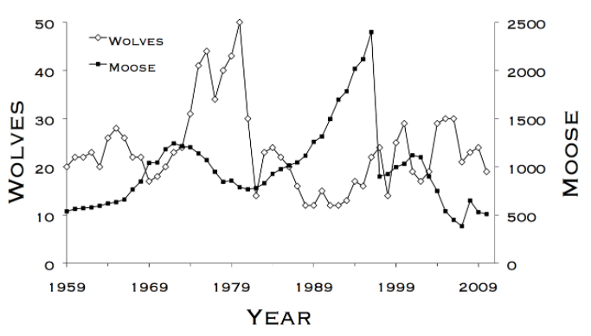
Discussion & Developing Ideas
- As a class, discuss your ideas about moose and wolf populations. What are ideas that most students agreed with? Where did your ideas differ as a class? Based on your instructor’s directions, use the space below or another option (e.g., whiteboard, online document, etc.) to record your ideas.
We all agree that…
We disagreed about…
- How does the size of wolf populations compare to moose populations? Why do you think this is? Write down your initial explanation in the space below. Don’t worry if you aren’t completely sure about your answer! You will come back and revise this explanation as you gain more information during this unit.
Wolf population sizes are usually smaller / larger / similar compared to moose populations because…

Part 2: Core Ideas
Overview: In this activity, you will begin with a short slideshow presentation. This will provide you with core ideas that will help you clarify your initial ideas. Your instructor will decide on how to implement this portion depending on your previous experience and capabilities with this content.
You will then work in small teams to answer the questions listed below. You should take notes in a notebook, on a dry erase board, or on scratch paper so that you are prepared to deliver your responses during the class discussion that will follow. Note: your instructor may assign specific questions to your group if time is limited.

Core Ideas Presentation: https://bit.ly/WUHS-Bio-EcosystemsW1
Driving Questions:
- What is an ecosystem? In what ways do living species depend on each other as well as the non-living components of their environments?
- What is biomass? How does the biomass of organisms relate to glucose molecules and soil minerals?
- What is the difference between producers and consumers? How is a primary consumer different from a secondary consumer? How do these terms relate to trophic levels?
- If a growing animal consumes 10 kg of plant biomass over the course of a week, how much mass would be added to the animal’s body? Explain using the term 10% Rule.
- True or false: the amount of plant, moose, and wolf biomass should be relatively equal in order for Isle Royale to be a stable ecosystem. Explain.
- What is the carrying capacity of an ecosystem? How does carrying capacity relate to biomass production and to the 10% Rule?
- What is biodiversity? How do levels of biodiversity relate to carrying capacity and biomass production?
- Tropical rainforests tend to have large numbers of different species per square mile. Why does more biodiversity exist in these ecosystems compared to most other regions of the planet?
- What is ecosystem resilience? What is an ecosystem disturbance? How are these terms related?
- How do changes to carrying capacity and biodiversity affect ecosystem resilience?
- Tundra and alpine ecosystems are often quite fragile. Why might it take years or even decades for these ecosystems to recover after disturbances? Why aren’t they more resilient?
- Revising Explanations: Return to your original explanation that you created at the end of Part 1. Based on this new information, how would you now respond to this question?
Wolf population sizes are usually smaller / larger / similar compared to moose populations because…

Part 3A Investigation: Fox Meadow Simulation
Adapted from Carbon TIME. Used with permission.
Introduction: This activity requires you to use a computer simulation to explore how changing populations of producers and consumers affects the stability and composition of a hypothetical ecosystem. Your instructor may choose to demonstrate how this program works for the entire class before letting you work in your groups.

Directions:
- Begin visiting the meadow computer simulation at https://carbontime.create4stem.msu.edu/sites/default/files/simulations/eco-simulation/index.html (or use an internet search engine and search for “Carbon TIME Meadow Simulation”). Use the worksheet on the following pages to record your responses.
- Set the initial mass for each population by dragging the sliders or typing in the boxes. Note that the maximum initial organic mass for each population is 1000 kg.
- Click the start arrow in the top right corner of the screen to run the simulation. On the simulation screen, use the buttons on the stopwatch at the bottom to pause the simulation (middle button), move ahead one year (right button), or to start a new run (left button)
Questions:
- Trial 1 – Set the following initial conditions, run the simulation, and complete the table below. (Note: After a run you can click on the graph to make a line appear. Drag the line to the year that you want to record the data for, and it will appear in the data table below the graph).
Fox Organic Mass: t = 0: 500 kg t ~ 50: t = 99:
Rabbit Organic Mass t = 0: 500 kg t ~ 50: t = 99:
Grass Organic Mass t = 0: 500 kg t ~ 50: t = 99:
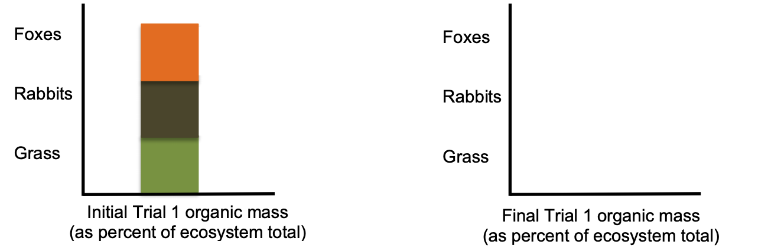
- Below is an organic mass diagram representing the initial conditions for trial 1. Sketch the final organic mass diagram for trial 1 (Notes: you can always get back to the lab book that records the data for each run by clicking the left button of the stopwatch to start a new run).
- Why do you think that the organic mass changed the way that it did in trial 1? Explain your reasoning.
- Trial 2 – Set the following initial conditions, run the simulation, and complete the table below.
Fox Organic Mass: t = 0: 1000 kg t ~ 50: t = 99:
Rabbit Organic Mass t = 0: 500 kg t ~ 50: t = 99:
Grass Organic Mass t = 0: 100 kg t ~ 50: t = 99:
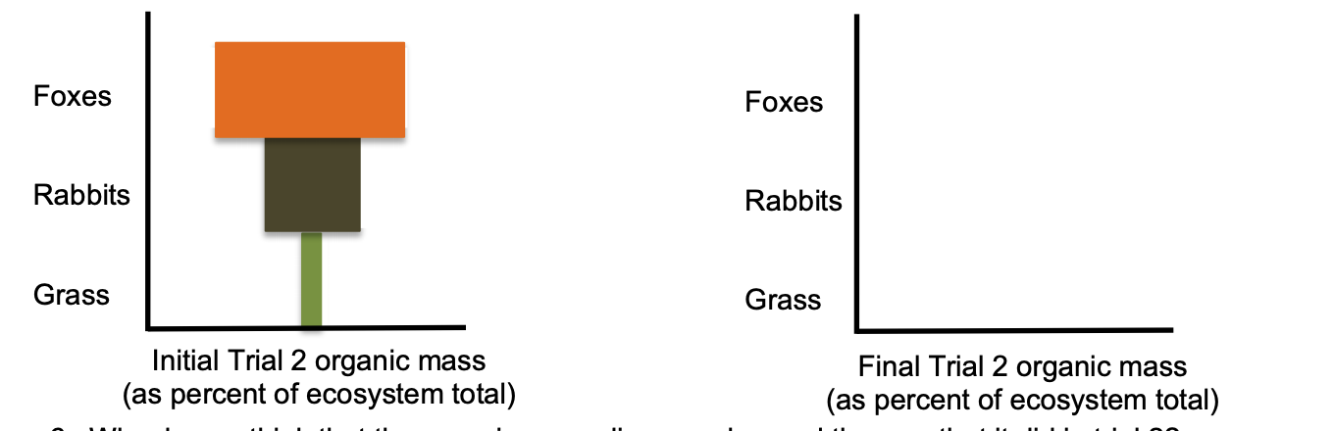
- Sketch the final organic mass diagram for Trial 2.
- Why do you think that the organic mass diagram changed the way that it did in trial 2? Explain.
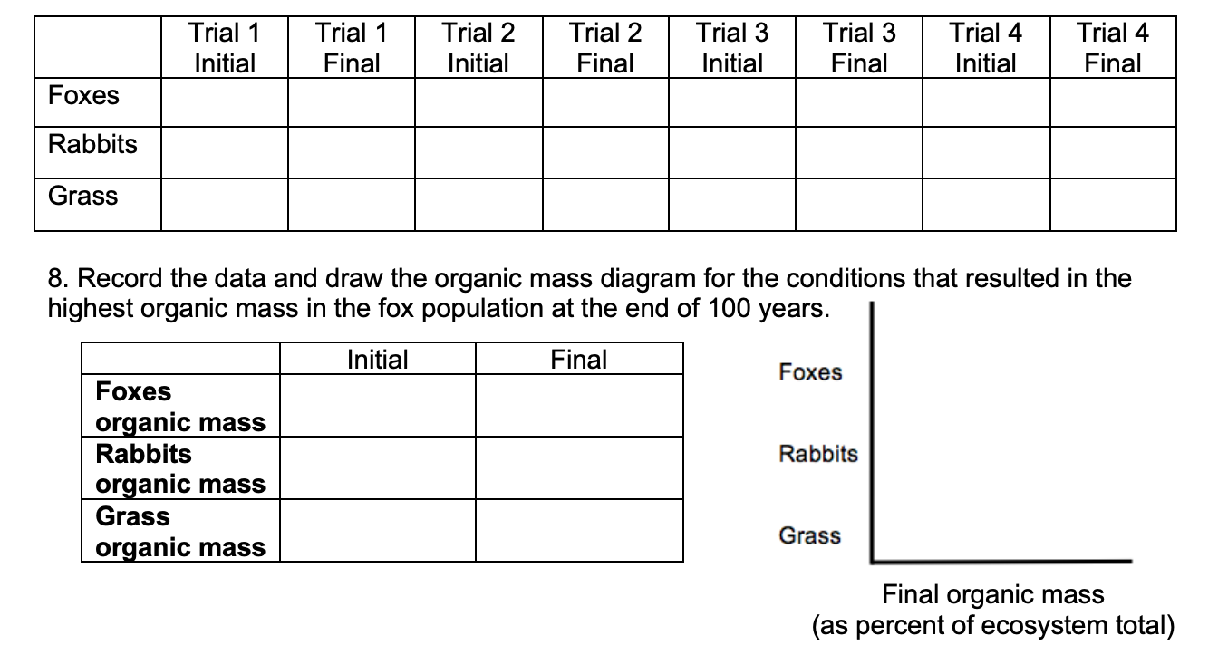
- Use the simulation to determine the maximum organic mass of foxes that the meadow ecosystem can support. Record your data for the initial final organic mass for each population in the table below.

Part 3B Investigation: Tabletop Ecosystems
Introduction: In this activity, you will be using a sealed container to create a simplified ecosystem. An ecosystem is a term used to describe how living organisms interact with each other and with the nonliving components in a given area. Your tabletop ecosystem is a tiny model that helps us to understand how much larger and more complicated ecosystems function.
A brine shrimp individual.
Source: Wikimedia Commons

Your tabletop ecosystem should contain only three kinds of organisms. The most obvious organisms are the brine shrimp. You should be able to see these tiny animals swimming throughout your ecosystem if you look closely. Less obvious are the phytoplankton. These are single-celled organisms that are similar to plants. They can photosynthesize (or convert CO₂ and H₂O into glucose and oxygen using the light energy). They may give the water a greenish color. Lastly, there are microbes in your tabletop ecosystem such as bacteria and microscopic fungi. These microbes will break down the biomass of the shrimp, phytoplankton, and other microbes when they die. This provides plants with minerals (e.g., N & P) as well as another source of CO₂.
Directions: As a group, observe your tabletop ecosystem. Address the questions below using your observations to guide your thinking. Use a notebook, dry erase board, or scratch paper to record your ideas. When you think you are ready, raise your hand. Your instructor will listen to your verbal responses.

Questions:
- Briefly summarize all the transformations of matter and energy that are occurring in this ecosystem.
  - What are some examples of cellular processes that enable energy transformation in this ecosystem? How is light, motion, chemical, or heat energy being transformed?
  - How is biomass being created from inorganic molecules in this tabletop ecosystem?
  - In what ways is biomass being converted back into CO₂ and H₂O in this ecosystem?
- Your tabletop ecosystem should be sealed so that air cannot be exchanged with the outside environment. Will your ecosystem run out of oxygen? Why or why not?
- What is more important to the function of this ecosystem – the phytoplankton or the shrimp? Why?
  - Could one exist without the other? Explain.
  - Which should be more abundant – the phytoplankton or the shrimp? Why?
- Biodiversity is a term used to describe the variety of different species in an ecosystem.
  - Is your tabletop ecosystem very biodiverse? Explain.
- Carrying capacity refers to the number of organisms that a habitat can support.
  - What primarily determines how many shrimp can exist within this ecosystem?
- A resilient ecosystem is one that could recover from a disturbance and still function.
  - Do you think that this tabletop ecosystem is resilient? Why or why not?
  - How might factors like carrying capacity and biodiversity affect ecosystem resiliency?
When you think you are ready, raise your hand. Your instructor will listen to your verbal responses.
This activity was successfully completed (instructor signature)

Part 4: Review & Assessment
Overview: For each objective, rank it as a 1 (completely unsure), 2 (somewhat unsure), or 3 (completely sure) based on your comfort with that objective. Then work in teams to review each item and prepare a response. You will conclude by completing a formative assessment.

Driving Questions
- What is an ecosystem? In what ways do living species depend on each other as well as the non-living components of their environments?
- What is biomass? How does the biomass of organisms relate to glucose molecules and soil minerals?
- What is the difference between producers and consumers? How is a primary consumer different from a secondary consumer? How do these terms relate to trophic levels?
- If a growing animal consumes 10 kg of plant biomass over the course of a week, how much mass would be added to the animal’s body? Explain using the term 10% Rule.
- True or false: the amount of plant, moose, and wolf biomass should be relatively equal in order for Isle Royale to be a stable ecosystem. Explain.
- What is the carrying capacity of an ecosystem? How does carrying capacity relate to biomass production and to the 10% Rule?
- What is biodiversity? How do levels of biodiversity relate to carrying capacity and biomass production?
- Tropical rainforests tend to have large numbers of different species per square mile. Why does more biodiversity exist in these ecosystems compared to most other regions of the planet?
- What is ecosystem resiliency? What is an ecosystem disturbance? How are these terms related?
- How do changes to carrying capacity and biodiversity affect ecosystem resiliency?
- Tundra and alpine ecosystems are often quite fragile. Why might it take years or even decades for these ecosystems to recover after disturbances?
- Revising Explanations: Return to your original explanation that you created at the end of Part 1. Based on this new information, how would you now respond to this question?
Wolf population sizes are usually smaller / larger / similar compared to moose populations because…

Part 5: Life Connections – Three Burritos
Adapted from Carbon TIME. Used with permission.
Directions: For this activity, read the paragraph below. Then decide which arguments sound most accurate. Be prepared to explain why.

Overview: Three students are at a restaurant. They decided they were all hungry for a burrito. However, they are struggling to decide what kind of burrito to eat. They have learned in their science classes that their choice of food can have an impact on the function and health of ecosystems around the planet.
These students have three options on the menu – 1) a vegetarian burrito (beans, cheese, and rice), 2) a chicken & cheese burrito, and 3) a beef & cheese burrito. They are aware that different types of food production will require different amounts of land and fuel. They also have heard that carbon dioxide levels are increasing, which can negatively affect human activity (including food production). While in line to order, they discuss their options and try to determine which option will result in the fewest ecological disturbances.

- Nina thinks that the bean burrito will be the most environmentally friendly option because it is a vegetarian option, which she argues is synonymous with being better for the environment.
- Daryll thinks that the bean burrito will have the highest carbon dioxide emissions because beans need to be harvested by a tractor, which burns diesel fuel. He intends to order the beef burrito because cattle eat grass, which absorbs CO₂.
- Marcos thinks that the chicken burrito is the best option because chickens are small. As such, they need less land and would exhale less CO₂ than cattle, and don’t require a tractor that burns fuel.
Who do you agree with and why? It’s ok to pick more than one person. Explain your thinking. In your explanation, provide evidence and reasoning that helps support your claim.
I most agree with the following: because…
What additional information do you need in order to know if your answer is accurate?
In what ways can your food choices affect the ecological processes that make food production possible?
Be prepared to discuss your ideas in small groups and as a class.
This page is intentionally blank. Use if needed for notes or other purposes.

Ecosystems Unit, Week 1 Assessment
Name: Hour Date: Score: /
Directions: A 3x5 notecard with handwritten notes can be used to guide your answers. Your instructor may allow you to work in assigned groups. If so, have a different person write each response while others assist.
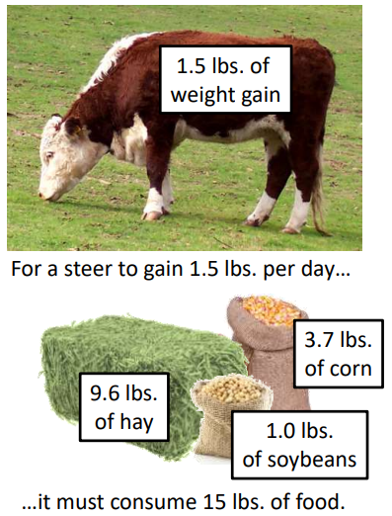
- The image at the right shows that in order to gain 1.5 lbs. of body mass per day, this animal has to consume roughly 15 lbs. of food. Why is it that only a small percentage of the mass of the consumed food stays inside the animal’s body? What is happening to most of the matter and energy in the consumed food?
Writer’s Name:

- A study* found that forests similar to those in Isle Royale contain an average of 135,000,000 g of plant biomass per hectare (a hectare is roughly the size of 2.5 football fields). Based on this data, what is the maximum grams of a) primary consumer biomass and of b) secondary consume biomass that could be supported per hectare of Isle Royale forest? Why? Explain your answers below.
(*Source: Tang et al., 2010).
Writer’s Name:
- The graph above shows changes in the wolf and moose population in Isle Royale National Park. Based on the data above, do you agree or disagree with each student’s claim?
  - Mike: "There will be more wolves because the wolves eat the moose." Agree/ Disagree
  - Lucia: "I think the population of moose and wolves should be about the same." Agree / Disagree
  - Oscar: “I think that there should usually be far more moose than wolves.” Agree / Disagree
- A) How did the wolf population change between the late 1970s to the late 1990s? B) How did the moose population change during this same time period? C) Using your understanding of trophic levels and the 10% Rule, predict why the moose and wolf populations changed in these ways.
Writer’s Name:
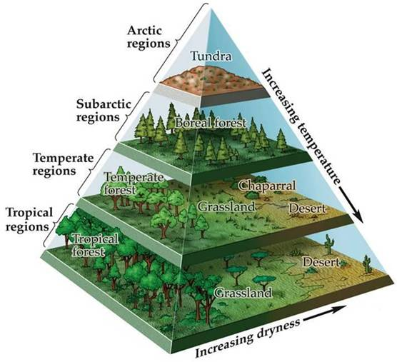
- Tropical rainforests often have large amounts of biodiversity, have large carrying capacities, and tend to be more resilient to disruptions. Alternatively, tundra ecosystems in places like Alaska and northern Canada have very little biodiversity, have low carrying capacities, and are more susceptible to threats and disturbances. Why is there a difference in biodiversity, carrying capacity, and resiliency between tropical rainforests compared to polar ecosystems? In your answer, be sure to address all of the following: biomass production; 10% rule; producers; consumers.
Writer’s Name:
- Oil spills have occurred in both Alaska and in Louisiana, resulting in extensive ecological disruption. Which ecosystems would recover more slowly, those in Alaska or those in Louisiana? Why?
Writer’s Name:

Ecosystems Unit - Week 1 Investigation Mastery Check
Name: Hour Date: Score: /11

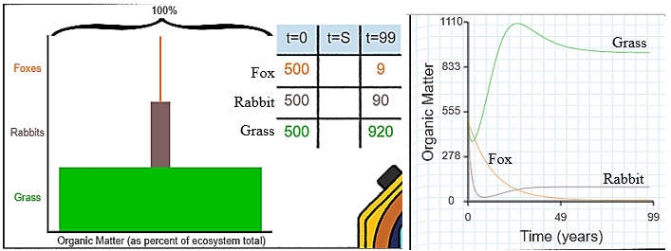
Use the data above from the Meadow Simulation to answer the questions below.
- The fox, rabbit, and grass populations each started with 500 units of biomass. Biomass can be defined as:
  - The variety of living species in a given area.
  - The total amount of atoms in the molecules of living organisms.
  - Whether an organism is a producer, primary consumer, or secondary consumer.
  - The number of organisms that an ecosystem can support.
- After a period of 99 years, this ecosystem contained 920 units of grass biomass, 90 units of rabbit biomass, and 9
units of fox biomass. These ratios reflect a principle in ecology known as
- The fox is an example of a… a) Producer b) Primary Consumer c) Secondary Consumer d) Decomposer
- Grass is an example of a… a) Producer b) Primary Consumer c) Secondary Consumer d) Decomposer
- Predict what would happen if the ecosystem started with 500 units of grass, 50 rabbit units, and 5 units of foxes.
  - The ecosystem would almost certainly collapse before reaching 99 years.
  - The units of foxes, rabbits, & grass would eventually become equivalent (e.g., all species at 500 units).
  - The units of foxes, rabbits, & grass would remain at their current proportions (500 grass:50 rabbits:5 fox).
  - It is not possible to make an accurate prediction with the information given.
- Which option below would be most likely to increase the carrying capacity and resiliency of this ecosystem?
  - Increase the amount of grass.
  - Increase the number of rabbits.
  - Increase the number of foxes.

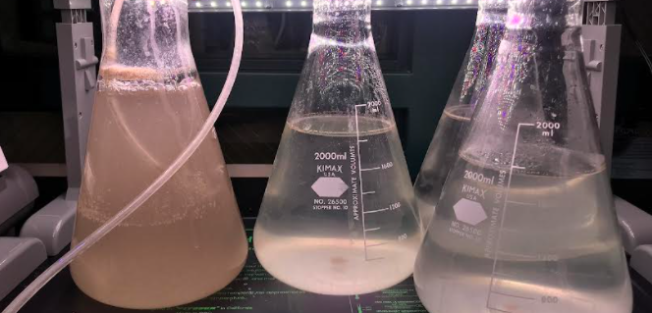
The image above shows the phytoplankton and shrimp as they were being grown for our investigation. Each container represents a separate ecosystem.
- Which should be more abundant in these ecosystems – the phytoplankton or the shrimp? Why?
  - The phytoplankton – they provide the initial source of biomass. This determines the carrying capacity of this ecosystem.
  - The shrimp – they provide the minerals and CO₂ needed for photosynthesis.
  - Both are equally important. Both populations should contain roughly the same amount of biomass.

- Which most determines how many shrimp can exist within these ecosystems?
  - Whether the container has 2000 ml of water or 1500 ml of water.
  - Whether or not the container has oxygen added from a pump.
  - The rate of photosynthesis among the phytoplankton.
  - The rate of cellular respiration in the shrimp.
- Which of the following would decrease the carrying capacity of these ecosystems?
  - Maintaining warm temperatures.
  - Providing adequate amounts of light.
  - Increasing the number of phytoplankton.
  - Adding equal amounts of primary and secondary consumers.
- Which of the following would decrease the resiliency of these ecosystems?
  - Maintaining warm temperatures.
  - Providing adequate amounts of light.
  - Increasing the number of phytoplankton.
  - Adding equal amounts of primary and secondary consumers.
- The container on the left contains significantly more shrimp than the containers on the right. Predict which of the following is most likely based on this information.
  - The left container will have the highest carrying capacity because it has the most consumers.
  - The left container is most at risk for an ecosystem collapse.
  - The left container will result in the greatest biomass production.
  - The left container will have the greatest oxygen production.

