DNA & Proteins Unit – Week 1

Score

□ Above & Beyond

□ Fully Complete

□ Mostly Complete

□ Incomplete – *fix the following pages*:

Name: Hour Date:

Date Packet is due:after Part 5 Why late?   
 If your work was late, describe why

**Semester Schedule**

**Traits & Genes**

Week 1 - What determines the traits of an organism?

Week 2 - How are traits inherited from parents?

Week 3 – Can we predict traits?

Week 4 - Assessment

**DNA & Proteins**

Week 1: What is DNA and how does it work?

Week 2: How does DNA affect protein assembly?

Week 3: How does a protein determine traits?

Week 4 - Assessment

**Mutations & Change**

Week 1: How do mutations change genes & proteins?

Week 2: How can mutations result in new traits?

Week 3: How can mutations lead to new species?

Week 4 - Assessment

**Biodiversity & Extinctions**

Week 1: How does biodiversity affect ecosystems?

Week 2: Why do some species go extinct?

Week 3: How can human activity cause extinctions?

Week 4 - Assessment

**Driving Question**: What is DNA and how does it work?

**Anchoring Phenomenon**: DNA tests are widely available today, but what does this information tell us? How can an analysis of different molecules tell us about a person’s traits? This week, we will dive deeper into DNA. What is DNA? What is it made from? And how can a molecule provide instructions for the assembly of another molecule?

**Weekly Schedule**

**Part 1: Introduction**

* Initial Ideas – What is DNA?
* Data Dive – How Does DNA Testing Work?
* Discussion & Developing Explanations

**Part 2: Core Ideas**

* Core Ideas
* Revisions of Part 1 Explanations

**Part 3: Investigation**

* Part 3A: DNA Models
* Part 3B: Licorice DNA

**Part 4: Review & Assessment**

* Ranking Your Readiness
* Assessment

**Part 5: Life Connections**

* Weekly Recap
* Life Connections – DNA Testing

**Deeper Questions**

1. What is DNA made from?
2. How does the structure of DNA determine its function?
3. How can a molecule provide instructions for the assembly of another molecule?

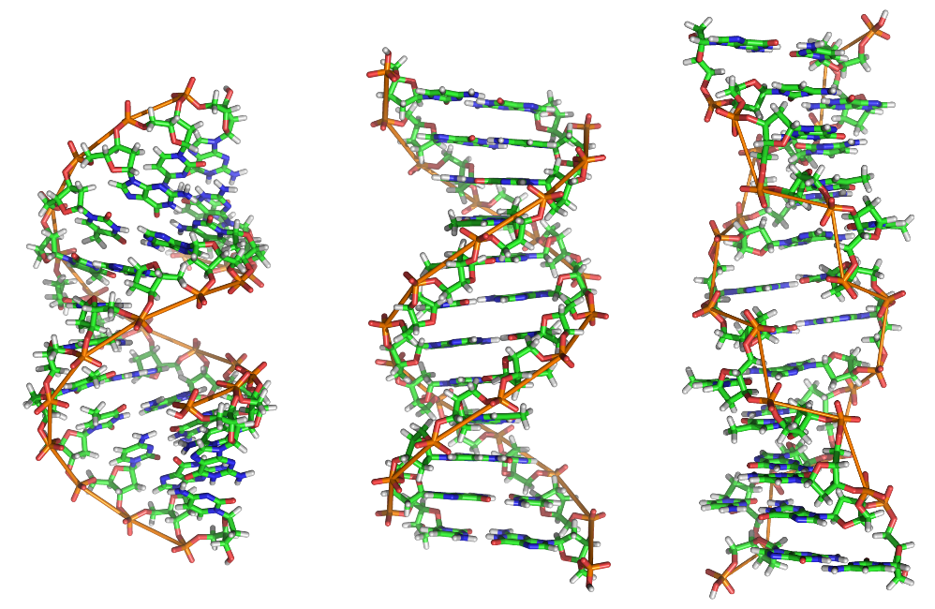

**NGSS Standards**:   
HS-LS1-1 - How the structure of DNA determines the structure of proteins and function.

HS-LS1-2 - How inheritable variations result from 1) changes via meiosis; 2) errors during replication; 3) mutations via environmental factors

HS-LS1-4: How mitosis and differentiation enable complex organisms.



Part 1: Introduction – DNA Testing

**Overview**: In this activity, you will begin by discussing your initial ideas about DNA. What is it? How can a molecule provide instructions to the cell? And how does DNA testing work?

**Initial Ideas**: Mike’s parents decided to have their family’s DNA tested. The test was very affordable and only required a small amount of saliva. Mike realized he really didn’t understand DNA, even though he had heard about it his entire life. Mike specifically remembered seeing portrayals of DNA in movies like *Spider Man* and *Jurassic Park*, and on TV shows like *Teenage Mutant Ninja Turtles*. However, he had no idea if how DNA was portrayed in popular culture had any relevance to how it works inside our cells in real life.

1. Three students shared their ideas about the cause of the variety of traits among living species. **Do you agree or disagree with each student’s claim**?
   1. Mike: " I think that DNA is sort of like a brain for our cells; it gives our cells their instructions so that they know how to function." Agree/ Disagree
   2. Lucia: "I think that DNA is what proteins are made from. Proteins are what do the work of the cell, so DNA must control how proteins are made." Agree / Disagree
   3. Oscar: “I know DNA is a molecule, and that must mean it is made from atoms. I also know that DNA is unique to each individual.” Agree / Disagree
2. **Work in your small groups to discuss your ideas.** How are your ideas similar or different? Decide as a group whether each statement is correct (and why). Be prepared to present your ideas to the class.

**Data Dive**: In this data dive, you will analyze multiple portrayals of DNA in popular culture. While watching the videos, decide where you agree, where you disagree, and where you are unsure about each portrayal.

**For each video, record your ideas about the following questions using a dry erase board, scratch paper, or a digital document. You should achieve a group consensus (if possible) for each of the following:**

* What was accurate about their portrayal of DNA?
* What was *inaccurate* about their portrayal of DNA?
* Which of these scenarios seem possible, if any? Which seem implausible? Why?
* What are you unsure about? What information do you still need?

**Videos**:

Video 1 – **Spider Man** - <https://www.youtube.com/watch?v=KYW-iST8VsE> (*A genetically-engineered spider bites Peter Parker, which results in Peter acquiring new genes for new spider-like traits*).

Video 2 - **Jurassic Park** – <https://www.youtube.com/watch?v=qUaFYzFFbBU> (*Scientists combine dinosaur DNA and frog DNA to bring dinosaurs back to life*).

Video 3 – **Captain America** - <https://youtu.be/MvdbKGB7JbI> (*To create a ‘super soldier’, Steve Rogers was injected with serum that altered his DNA; the serum was activated by intense light*).

**What is DNA and how does it work?** Write down your initial explanation in the space below. Don’t worry if you aren’t completely sure about your answer! You will come back and revise this explanation as you gain more information during this unit.

Part 2: Core Ideas

**Overview**: In this activity, you will begin with a short slideshow presentation. This will provide you with core ideas that will help you clarify your initial ideas. Your instructor will decide on how to implement this portion depending on your previous experience and capabilities with this content.   
  
You will then work in small teams to answer the questions listed below. You should take notes in a notebook, on a dry erase board, or on scratch paper so that you are prepared to deliver your responses during the class discussion that will follow. *Note: your instructor may assign specific questions to your group if time is limited.*

**Intro Video – DNA Basics**: <https://ed.ted.com/lessons/the-twisting-tale-of-dna-judith-hauck>

**Core Ideas Presentation**: <https://bit.ly/WUHS-Bio-DNAProteinsW1>

**Driving Questions**:

1. How are traits used to classify different species from each other? How do these traits relate to cells, DNA, and proteins?
2. What is the primary purpose of DNA? How does DNA enable a cell to function?
3. What molecules are found in a DNA macromolecule? What is the purpose of each component of DNA?
4. How are the components of each nucleotide similar to the components of a spiral notebook?
5. What are complementary base pairs? Explain why nucleotide bases always combine in specific ways.
6. What is the function and purpose of helicase and polymerase proteins?
7. How do complementary base pairs, helicase, and polymerase each enable DNA to be replicated?
8. What provides a sense of direction within a DNA macromolecule as it is being copied? Explain.
9. What are codons? How do they enable DNA to provide instructions for assembling a protein?
10. What determines the start and end of a gene?
11. **Revising Explanations**: Return to your original explanation that you created at the end of Part 1. Based on this new information, how would you now respond to this question?

**What is DNA and how does it work?**

Part 3A Investigation: DNA Models  
[*Adapted from materials by Karen Mayes*](https://smithsworldofscience.weebly.com/uploads/1/0/5/5/10557615/dna_model_parts_for_your_presentation.pdf)

**Overview**: In this investigation, you will use models to determine how to assemble molecules to form a DNA macromolecule.

**Pre-Investigation Questions:** Work as a group to determine the best response to each question. Be prepared to provide verbal answers for some of these questions for your instructor before you complete the investigation.

1. *What is the primary purpose of DNA? How does DNA enable a cell to function?*
2. *What molecules are found in a DNA macromolecule? What is the purpose of each component of DNA?*
3. *What are complementary base pairs? Why do bases always form these two combinations? (2 reasons)*
4. *What is the function and purpose of helicase and polymerase proteins?*
5. *What are codons? How do they enable DNA to provide instructions for assembling a protein?*

When you think you are ready, **raise your hand**. Your instructor will listen to your verbal responses.   
  
*This activity was successfully completed* (*instructor signature*)

**Methods:** Check each box as you complete each step.

1. ☐ First, acquire a paper copy of the DNA components.
2. ☐ Use markers or colored pencils to give each component a separate color (*you can either fill in the entire component with color or just trace color around the edge of that item*).
3. ☐ Next, use a scissors to cut out each component.
   1. Place each component in separate piles.
4. ☐ Assemble a nucleotide by matching symbols on each component to determine how each piece fits together (for example, a star on one component would bond to a star on another component).
   1. Each nucleotide consists of a base molecule, a sugar molecule, and a phosphate molecule.
   2. Do not tape or glue your nucleotide yet.
5. ☐ Arrange nucleotides (base, sugar, & phosphate) in the following order: **T A C G T A T G A A A C**
6. ☐ Arrange nucleotides to fill in the opposite side of this DNA molecule (remember, T can only pair with A, and G can only pair with C).
7. ☐ Check with your instructor to make sure your work is accurate.
8. ☐ Once your instructor has confirmed your work is accurate, connect each component using tape or glue.

*Be prepared to discuss and defend your ideas in small groups and as a class.*

Part 3B Investigation: Licorice DNA  
Adapted from the [Genetic Science Learning Center](https://teach.genetics.utah.edu/content/dna/Have-Your-DNA-and-Eat-It-Too.pdf)

**Overview**: In this investigation, you will use licorice, toothpicks, and marshmallows to create an edible model of DNA. After explaining how the structure of DNA relates to its function, you will be able to consume your creation.

**Materials needed** (per group of 4): 2 pieces of licorice, 12 toothpicks, a variety of colored marshmallows (with 4 different colors: green, pink, yellow, and orange), masking tape, pen/pencil.

**Methods:** Check each box as you complete each step.

1. ☐ Assemble one side of the DNA molecule using the sequence below.
   1. A piece of licorice will form the backbone and marshmallows will be the chemical bases.
   2. Place a marshmallow on the end of a toothpick so that the point of the toothpick goes all the way through.
   3. Anchor the toothpick into the licorice backbone.
   4. Diagram

      Description automatically generatedRefer to the table to choose the correct color marshmallow to represent the chemical bases in this sequence:   
      T A C G T A T G A A A C
2. ☐ Match the chemical base pairs.
   1. Place the color marshmallow for the matching chemical base on the other end of each toothpick.
   2. Remember that A always pairs with T and C always pairs with G!
3. ☐ Complete your DNA model.
   1. Attach the other backbone so your model looks like a ladder.
   2. Carefully twist your DNA molecule so that it looks like a double helix.
4. ☐ Label your model.
   1. Use masking tape to label the parts of your DNA.
   2. Label one of each of the following: *Adenine, Thymine, Cytosine, Guanine, and Phosphate,* and *Sugar*.
   3. Make sure your chemical base pairs are correct!

Part 4: Review & Assessment

**Overview:** Rank each Driving Question in Part 2 as a 1 (*completely unsure*), 2 (*somewhat unsure*), or 3 (*completely sure*) based on your comprehension. Then work in teams to review each item and prepare a response. Next, write a final explanation below. You will conclude by completing a formative assessment.

**What is DNA and how does it work?**

Part 5: Life Connections – DNA Testing

**Directions:** For this activity, you will consider three claims about DNA testing. You will then use internet search engines to obtain more information about this topic. You will also critique your sources for credibility.

**Overview**: Mike’s parents decided to have their family’s DNA tested. The test was affordable and only required a sample of saliva. The testing kit explained that they would receive their results within a month of mailing in a sample of their saliva. However, Mike is not entirely sure what kind of information this test would provide.

Mike and his friends are in the midst of a unit on DNA in their biology class. During lunch, they discuss their ideas. Here’s what they thought:

*Mike: I remember hearing that DNA tells the cell how to function. So a DNA test must provide some information on how a person’s cells work.*

*Lucia: I remember it differently; I thought that DNA was how your body got its traits. So DNA must be for the whole body, not just the cell. A DNA test would tell you things about your whole body.*

*Oscar: I know that DNA has something to do with proteins. So the DNA test must tell you about what proteins your body is producing.*

**Who do you agree with and why?** It’s ok to pick more than one person. Explain your thinking.

I most agree with the following: because

**Investigation:** Next, use the directions below to obtain more information about how DNA testing works using an internet search engine.

1. Visit the following website: <https://medlineplus.gov/genetics/understanding/testing/genetictesting/>   
   (or type “*What is genetic testing?*” into an internet search engine to find the MedlinePlus article).
2. Briefly read the content of this website and identify key points. Skim the article if time is limited.
3. Work with your group to address *each* of the following. Record your responses in this [Google doc](https://forms.gle/HQchByVL5oEbR4qT8):  
   <https://forms.gle/HQchByVL5oEbR4qT8>
   1. **Credibility**: Who is the author? What are their credentials? Are they sufficiently qualified to provide this kind of information? Who is sponsoring or publishing this information?
   2. **Accuracy**: Does this information seem accurate based on what you already know about this topic? Do you have any reason to be concerned about accuracy in this source?
   3. **Reliability**: Does the website present a certain bias or viewpoint?
   4. **Relevance**: Does this website sufficiently enable you to address your questions about this topic?
   5. **Date**: When was this information published? Is it still relevant, or is it potentially out of date?
   6. **Sources**: Does the author cite their sources? Are their sources credible?
   7. **Overall**: Based on your responses, do you think this is a good source to use for you research?
4. Use a search engine to find at least one more source at address your questions. Repeat this process.
5. As a group, use this information to explain what kinds of information a DNA test can provide.
6. Be prepared to discuss your group’s findings in a class discussion. Choose a spokesperson for each consideration.

DNA & Proteins Unit - Week 1 Formative Assessment

Name: Hour Date: Score: /

**Directions**: A 3x5 notecard with handwritten notes can be used to guide your answers. Your instructor may allow you to work in assigned groups. If so, have a different person write each response while others assist.

1. **A) What is the primary function of DNA? B) Predict what would happen to a cell if it did not have its own copy of DNA.** Include and underline the following terms: *traits, proteins, genes.*   
     
      
     
      
     
      
   *Writer’s Name:*
2. Three students shared their ideas about the cause of the variety of traits among living species. **Do you agree or disagree with each student’s claim**?
   1. Mike: "DNA is like the brain of a cell. It tells a cell how to function." Agree/ Disagree
   2. Lucia: "DNA is what determines an organism’s traits, like size or hair color." Agree / Disagree
   3. Oscar: “DNA provides the instructions for how to assemble proteins.” Agree / Disagree
3. **Which claim(s) is/are most accurate**? **Why**?   
     
      
     
      
     
      
   *Writer’s Name:*
4. **What is the role of helicase and polymerase during replication of DNA? How do these proteins ensure that DNA can be accurately duplicated?**  
      
     
      
     
      
     
      
   *Writer’s Name:*
5. 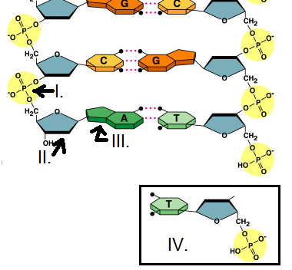Using the image at the right, **A) explain what each numbered item (I-IV) represents. Then B) describe the function of each of these components in a DNA macromolecule.**    
      
     
      
     
      
     
      
     
      
     
      
     
      
     
      
     
      
   *Writer’s Name:*
6. An analysis of a sample of human DNA found that it was comprised of 31% A’s, 19% C’s, 19% G’s, and 31% T’s. **A) What pattern(s) do you notice in the percentage of each base? B) What might explain these patterns? C) How does this pattern relate to how DNA is duplicated?**  
      
     
      
     
      
     
      
     
      
     
      
   *Writer’s Name:*

