The Big Bang – Week 1 Labwork
Score
□ Above & Beyond
□ Fully Complete
□ Mostly Complete
□ Incomplete – fix the following pages:
Name: Hour Date:
Date Packet is due: Why late? Score:
^{Day of Week Date} If your project was late, describe why
Driving Question: How can we determine the universe’s size?
Semester Schedule
How the Sun Works
Week 1: What is matter? What is energy?
Week 2: What’s inside the sun?
Week 3: How can we measure the sun?
Week 4: Where does the sun’s energy come from?
Week 5: Unit Assessment
The Life of Stars
Week 1: How long do stars last?
Week 2: Why do stars die?
Week 3: What happens after stars die?
Week 4: Unit Assessment

How It All Began
Week 1: How can we determine the universe’s size?
Week 2: How can expansion determine the universe’s age?
Week 3: Unit Assessment

Navigating Space
Week 1: How and why do things orbit in space?
Week 2: How can we predict orbits?
Week 3: Unit Assessments

Anchoring Phenomenon: How does light change based on distance and velocity, and how can these differences be useful for determining changes in the size of the universe as it ages?

Deeper Questions
- How can we make conclusions about the size and age of the universe based on how light changes over large distances?
- How is the size of the universe changing over time?
- What do these changes indicate about the origins of the universe?

Weekly Schedule

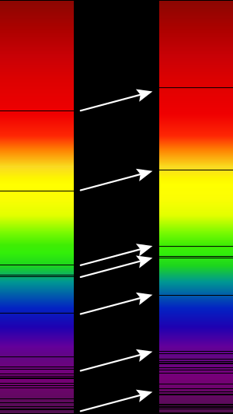
Part 1: Introduction
- Initial Ideas – Red Shift
- Discussion & Developing Explanations

Part 2: Core Ideas
- Core Ideas
- Revisions of Part 1 Explanations

Part 3: Investigation
- Part A – The Doppler Shift Demo
- Part B – Distances in Inflating Balloons

Part 4: Review & Assessment
- Critiquing Ideas
- Assessment

Part 5: Side Quest
- Weekly Recap
- Side Quests
NGSS Standard:
HS-ESS1-2: Construct an explanation of the Big Bang theory based on astronomical evidence of light spectra, motion of distant galaxies, and composition of matter in the universe.

Part 1: Initial Ideas About Red Shift
Overview: In this activity, you will begin by discussing your initial ideas about the age and size of the universe.
Initial Ideas: Three astronomy students are discussing their ideas about the origins of the universe. They have been in astronomy class for a couple months and have gain some knowledge about stars.
- Do you agree or disagree with each student’s claim?
  - Antonia: "I think that while stars have a limited lifespan, the size and age of the universe are infinite. The universe has always existed and it is infinitely large – it goes on forever." Agree / Disagree
  - Edwin: "I disagree. I think that the universe had to come from somewhere. It may be infinitely large, but it did not exist forever." Agree / Disagree
  - Cecilia: “I disagree with both of you. I think that the universe has a specific age and a specific size. It has existed for a specific number of years and is a specific distance in diameter.” Agree / Disagree
- Work in your small groups to discuss your ideas. How are your ideas similar or different? Decide as a group whether each statement is correct (and why). Be prepared to present your ideas to the class.
Data Dive: In this activity, you will use the data from spectral analysis (below) to develop your initial ideas about how differences in light enable astronomers to draw conclusions about the size and age of the universe.
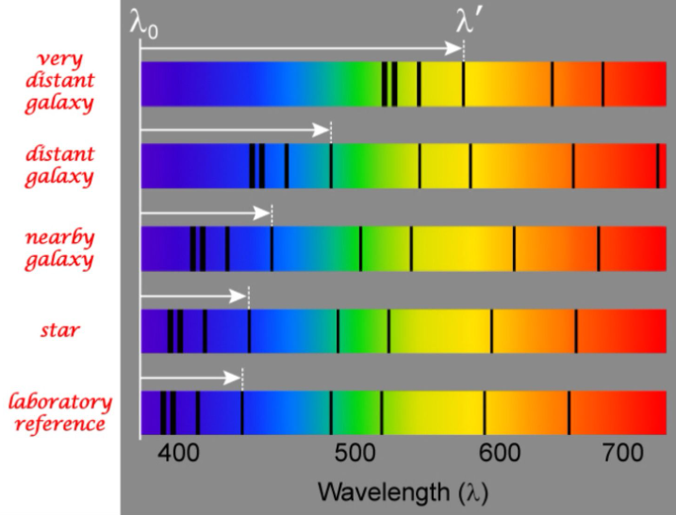
Background: An astronomer is comparing the light of four similar stars. Each star is similar in size and atomic composition. These four stars exist at a variety of different distances from earth; for simplicity, the exact distances are omitted.

When the star’s light passed through its outer layers, the electrons of in its atoms absorbed the light. These electrons then re-emit light in particular ways based on the kinds of elements in those layers.

The light of these stars was focused through a telescope and diffracted using a prism. This yields a spectral signature, or a pattern of lines in the diffracted light. This data is shown here. Red wavelengths are on the right and blue wavelengths are on the left. These data are compared to a laboratory reference for spectral analysis of a gas with the same atomic composition.

Use this information to answer the questions on the next page.
(Image Source: Pinterest)

- Begin by individually attempting to make sense of this data. What trends or patterns do you notice? How does this relate to any prior knowledge or experience that you have?
- Next, work in your teams to discuss your ideas. Where do you agree? Where do you disagree? Can you use this data to reach agreement? Do others have prior knowledge/experience that could help?
- Based on this data, what is one conclusion that would be supported by this data?
  - How is this conclusion supported by this data?
  - What specifically suggests that your claim is accurate?
- Based on this data, what is a second conclusion that would be supported by this data?
  - How is this conclusion supported by this data?
  - What specifically suggests that your claim is accurate?
- Would you change any of your responses to the first question above? (See Question #1 under Initial Ideas). Discuss as a team.
- As a class, discuss your ideas about this data. What are ideas that most agreed on? Where did your ideas differ as a class? Record your ideas in the spaces below.
We disagreed or are unsure about…
We all agree that…
- What conclusions can we draw from the patterns and trends in this graph? Does this seem to indicate anything about the size or age of the universe? Write down your initial explanation in the space below. Don’t worry if you aren’t completely sure! You will have opportuninites to revise.

Part 2: Core Ideas
Overview: In this activity, you will look at a short slideshow presentation. This will provide you with core ideas that will help you clarify your initial ideas. Your instructor will decide on how to implement this portion depending on your previous experience and capabilities with this content.
You will then work in small teams to answer the questions listed below. You should take notes in a notebook, on a dry erase board, or on scratch paper so that you are prepared to deliver your responses during the class discussion that will follow. Note: your instructor may assign specific questions to your group if time is limited.

Intro Video: https://www.yout-ube.com/watch?v=hVApTLE7Csc
Core Ideas Presentation: https://bit.ly/WUHS-Astro-BigBangW1

Driving Questions:
- What is a Cepheid variable? How can this be used to determine astronomical distances?
- What is the difference between luminosity, apparent magnitude, and distance? How does this relate to the rate of pulsation of Cepheid variables
- Summarize Harlow Shapely’s work, his findings, and his errors.
- How did Hubble confirm that the Milky Way was just one galaxy among many in the universe?
- Summarize the concept of redshift and how it relates to the distance of the object emitting the light.
- What is Hubble’s Law? What is Hubble’s Constant? What do these concepts indicate about the universe?
- Define a megaparsec and use it to explain the concepts underlying Hubble’s Constant.
- What is CMBR and how does its existence provide evidence for the Big Bang?
- True or false: the further an object is from earth, the faster it is moving; therefore, the earth must be at the center of the universe. Explain.
- How is the expansion of the universe, redshift, and Hubble’s Law summarized by the inflating balloon analogy?
- How is the expansion of the universe and Hubble’s Law supported by Einstein’s Theories of Relativity?
- What was Einstein’s cosmological constant and what made it erroneous?
- Revising Explanations: How can we determine the size and/or age of the universe?

Part 3A: Investigation – Doppler Shift
Overview: You will use phones or recording devices to investigate the Doppler Shift in sound. You will then use this as a conceptual model to explore how and why the redshift occurs in light from receding galaxies.

Background (adapted from Exploratorium): Have you ever noticed how the sound of a siren changes as the vehicle moves? As the siren approaches you, the waves of sound are squeezed together; you hear them as being higher-pitched. After the vehicle passes by, siren’s sound waves are stretched apart. You hear these stretched waves as being lower-pitched. This apparent change in the pitch (or frequency) of sound is called Doppler Shift.
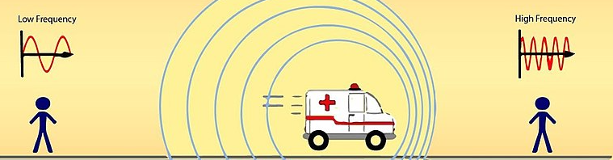
Image sources: Wikimedia
Light from distant stars and galaxies can be shifted in much the same way. Like sound, light is a wave that can be described in terms of its frequency. Frequency refers to the number of wave peaks that pass by each second.

If a star is moving toward earth, its light waves are squeezed together. This increases the frequency of those wavelengths of light. Since blue is at the high-frequency end of the visible spectrum, light from an approaching star is shifted toward blue (blueshifted).

If a star is zooming away from you, its light waves are stretched. You see these stretched-out light waves as having a lower frequency. This causes light from a receding star to shift toward red (redshifted).
Directions: use an approved recording device (such as a digital recorder or a voice-memo app on a phone).
- Move to a large open area that is appropriate for excess noise (such as a gym or practice field).
- In your assigned groups, choose a) one person to be a runner, b) one person to be a running recorder, and c) one person to be a standing recorder.
- The runner will sprint a short distance (100 meters or so). While sprinting, the runner should make a loud humming noise at a constant pitch and volume.
- The running recorder will capture audio as they run alongside the runner.
- The standing recorder will stand at the midpoint of their sprint and record audio as they run past.
- Compare the differences between the two sources of audio. Use this audio to address these questions.
Questions:
- What explains the differences between the audio from the running recorder vs. the standing recorder?
- How did the frequency of the audio waves change as the runner sprinted past the standing recorder?
- How is this analogous to redshift and blueshift in astronomy?
- How does the amount of redshift from a receding galaxy’s light correlate to the distance and speed at which that galaxy is moving?
- When ready, raise your hand. Your instructor will determine if you are ready to move on.
This activity was successfully completed (instructor signature)

Part 3B: Investigation – Inflating Balloons
Background: Hubble’s Law states that the rate at which a galaxy is moving away is proportional to its distance from that point; i.e., the further away the galaxy, the faster it is moving. In this investigation, you will model this phenomenon using a balloon. You will compare how distances between different points change as the balloon inflates.

Directions:
- In your assigned groups, acquire the following materials: inflatable balloons (such as standard party balloons); permanent marker; flexible rulers.
- Inflate the balloon just enough so that the balloon can hold its own shape. Have someone hold the balloon so that it doesn’t leak any air.
- Draw an X somewhere on the balloon with a permanent marker.
  - Draw a circle roughly 3 cm (~1 inch) from the X.
  - Draw a square roughly 5 cm (2 inches) from the X.
  - Draw a triangle 10 cm (4 inches) from the X.
- Record the initial distances in the table below.
- Inflate the balloon more (but stop before it is fully inflated). Record the new distances below.
- Inflate the balloon a final time (but not so much that it pops, or you’ll need to start over). Record the final distances below.
- Use the data you collected to create a graph. Then answer the accompanying questions.
Data:
 | Initial (cm) | 2nd Inflation (cm) | Final Inflation (cm)
X --> Circle Distance
X --> Square Distance
X --> Triangle Distance

Graph this data below. Provide labels for the x- and y-axis as well as any other components as needed.

Questions:
- Assume that a minute passed between each inflation (regardless of how much time actually elapsed). How did the speed (cm/min) at which the circle moved away from the X compare to the speed at which the triangle moved away? What does this indicate about the distance between objects and their velocity?
- In this activity, we can measure the distance between different objects with a ruler. How do astronomers measure the distance between different galaxies. In your response, including and explain the following terms: Cepheid variable; luminosity; apparent magnitude; pulsation.
- In this activity, the circle, square, and triangle you drew represented distant galaxies. Would the light from these galaxies be affected by redshift, blueshift, both, or neither? Explain how you would know.
- How does this activity relate to Hubble’s Law & Hubble’s Constant? Explain your reasoning.
- Would Einstein’s cosmological constant apply to this exercise? Explain your reasoning.
- When ready, raise your hand. Your instructor will determine if you are ready to move on.
This activity was successfully completed (instructor signature)

Part 4: Review & Assessment
Overview: Rank each Driving Question in Part 2 as a 1 (completely unsure), 2 (somewhat unsure), or 3 (completely sure) based on your comprehension. Then work in teams to review each item and prepare a response. Next, write a final explanation below. You will conclude by completing a formative assessment.
Revising Explanations: How can we determine the size and/or age of the universe?

Part 5: Side Quest
Overview: For this activity, you will then identify topics related to astronomy that you personally find interesting to investigate more deeply over the remainder of the semester.
Side Quest: In this activity, you will begin to identify some topics related to astronomy to investigate more deeply over the course of the semester. Be prepared to discuss the following with your instructor.

- Summarize the topic that you would like to investigate as your side quest.
- Why did you choose this topic? Why do you find this topic interesting or intriguing?
- What is your learning objective for this project? In other words, what do you want to learn and what do you want others to know by the time you finish your presentation?
- Are you working alone or with a group? If in a group, how will you divide the work?
- What is your strategy for developing a presentation? How will you effectively teach this topic?
- Is this topic appropriate for the time available to you?
- Are you excited about this topic? Is it something that is personally interesting to you?
This page is intentionally blank.

Big Bang – Week 1 Assessment
Name: Hour Date: Score: /
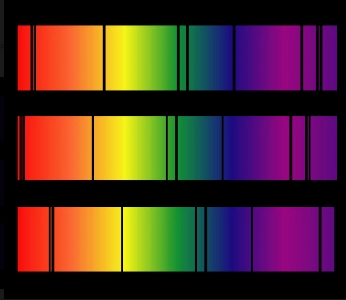
Directions: This is an open-notes quiz. You should work with your assigned team to complete responses to the questions below. Each person should write the response to at least one question. Write your initials next to the answer(s) you wrote. Those who are not writing should collaborate to create the response that will be written.

- Data from spectral analysis is show in the image to the right. Red is on the left; blue is on the right. The top diffraction is from our sun. The second diffraction is from Star X while the third is from Star Y. Based on this data, what can we determine about each of these other stars? Justify your stances with evidence and reasoning.
Initials:
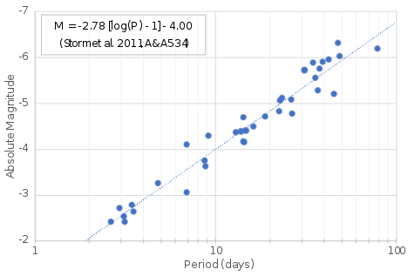
- Data from various Cepheid variables is shown at the right. Explain what this indicates about the relationship between period (or pulsation rate) and absolute magnitude (or luminosity). Then explain how this data can be used to determine the distance of that star based on apparent magnitude.
Initials:

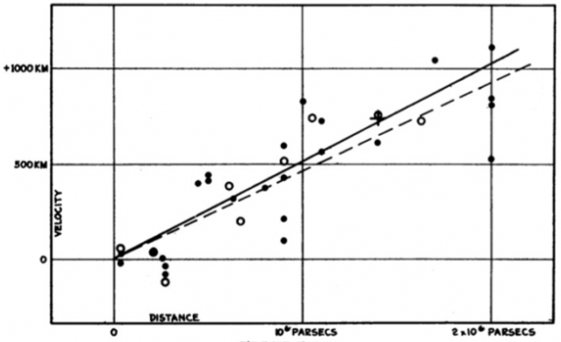
- This graph shows the correlation between the distance (in parsecs) and velocity of a galaxy. Use this graph to explain this relationship. Then summarize how this data relates to Hubble’s Law and Hubble’s Constant.
Initials:
- What is CMBR and how does it provide evidence for the validity of the Big Bang theory?
- The further an object is from earth, the faster it is moving. Does this mean that the earth is the center of the universe? Explain with evidence and reasoning.
Initials:
- How do Einstein’s Theories of Relativity relate to the Big Bang theory? In your response, include an explanation of Einstein’s cosmological constant.
Initials:

