Mutations & Change Unit – Packet 1
Score
□ Above & Beyond
□ Fully Complete
□ Mostly Complete
□ Incomplete – fix the following pages:
Name: Hour Date:
Date Packet is due: after Part 5 Why late?
If your work was late, describe why
Semester Schedule
Traits & Genes
Packet 1 - What determines the traits of an organism?
Packet 2 - How are traits inherited from parents?
Packet 3 – Can we predict traits?
Packet 4 - Assessment

DNA & Proteins
Packet 1: What is DNA and how does it work?
Packet 2: How does DNA affect protein assembly?
Packet 3 – Assessment
Packet 4 – How are new genes added to DNA? (Mini-Unit)

Mutations & Change
Packet 1: How does a protein acquire its shape & function?
Packet 2: How do mutations change genes & proteins? Packet 3: How can mutations lead to new traits & species?
Packet 4 – Assessment
Packet 5 – How Does Antibiotic Resistance Occur?

Biodiversity & Extinctions
Packet 1: How does biodiversity affect ecosystems?
Packet 2: How and why do extinctions occur?
Packet 3: Final Assessment

Driving Question: How does a protein acquire its shape & function?
Anchoring Phenomenon: We now know what DNA is made from, and how it is copied by mRNA. We still haven’t determined how a chain of amino acids forms a protein with a specific shape and function. We will use a genetic disease called sickle cell anemia to explore this idea further.

Weekly Schedule

Part 1: Introduction
- Initial Ideas – Sickle Cell Anemia
- Data Dive – Differences in Protein Shapes
- Discussion & Developing Explanations

Part 2: Core Ideas
- Core Ideas
- Revisions of Part 1 Explanations

Part 3: Investigation
- Part 3: Pipe-cleaner Proteins

Part 4: Review & Assessment
- Ranking Your Readiness
- Formative Assessment & Mastery Check

Part 5: Life Connections
- Weekly Recap
- Life Connections – CRISPR & SCA

Deeper Questions
- How does a chain of amino acids form a functional protein?
- How do the properties of the amino acids determine the shape and function of the protein?
- What happens if the order of amino acids in a protein is changed?

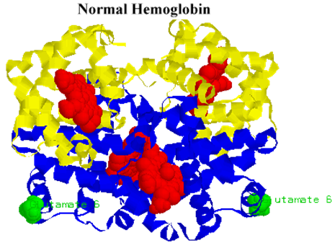
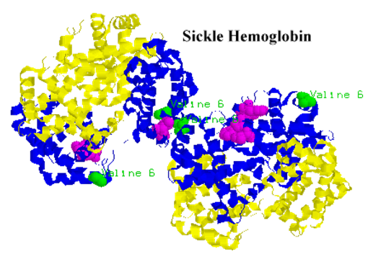
NGSS Standards:
HS-LS1-1 - How the structure of DNA determines the structure of proteins and function.
HS-LS1-2 - How inheritable variations result from 1) changes via meiosis; 2) errors during replication; 3) mutations via environmental factors
HS-LS1-4: How mitosis and differentiation enable complex organisms.

Part 1: Introduction – Sickle Cell Anemia
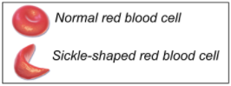
Overview: In this activity, you will begin by discussing your initial ideas about how changes in DNA and amino acid chains can affect the formation of functional proteins.

Initial Ideas: Some members of Daryll’s extended family carry genes for a genetic disease called sickle cell anemia. This disease causes symptoms such as blood clots, painful swelling, and reduced oxygen content in the blood.

Daryll recently learned that sickle cell anemia results from a change to a base molecule in the gene for hemoglobin. Hemoglobin is the protein that binds to oxygen in red blood cells. If the gene changes, the protein’s shape changes. This changes red blood cells from a donut-shape to a half-moon shape.

Daryll is unclear why changing a single base in a gene would affect proteins, change cells, and harm the entire body. He discusses this with his friends at lunch. They each share their ideas.
- Do you agree or disagree with each student’s claim?
  - Daryll: "I know that DNA provides the instructions for assembling a protein. Maybe changing one base changes the entire DNA" Agree/ Disagree
  - Avery: "I know that DNA is read in groups of 3 bases. The entire protein must have changed because a single amino acid was changed." Agree / Disagree
  - Chandra: “This makes sense – if proteins are made from DNA, then changing the DNA will change the protein.” Agree / Disagree
- Work in your small groups to discuss your ideas. How are your ideas similar or different? Decide as a group whether each statement is correct (and why). Be prepared to present your ideas to the class.
Data Dive: In this data dive, you will make observations about differences in genes and protein shape that occur in sickle cell anemia. Use the images below to answer the questions on the following pages.

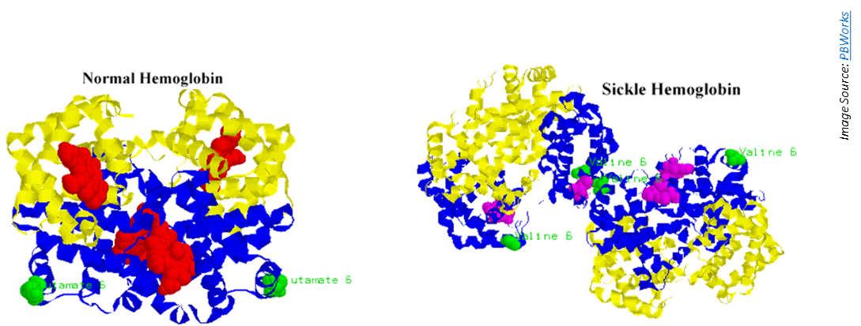
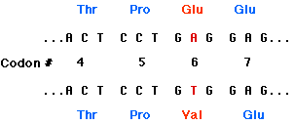
Normal Gene

Sickle Cell Gene

- Begin by individually attempting to make sense of these image. What trends or patterns do you notice? How does this relate to any prior knowledge or experience that you have?
- Next, work in your teams to discuss your ideas. Where do you agree? Where do you disagree? Can you use this data to reach agreement? Do others have prior knowledge/experience that could help?
- Based on this data, what is one difference you can observe between the normal and sickle cell genes and/or proteins?
  - How is this conclusion supported by this data?
  - What specifically suggests that your claim is accurate?
- Based on this data, what is a second difference you can observe between the normal and sickle cell genes and/or proteins?
  - How is this conclusion supported by this data?
  - What specifically suggests that your claim is accurate?
- How does this data pertain to the three claims from on the previous page? (See Question #1 under Initial Ideas). Discuss as a team.
- Discussion & Developing Ideas: As a class, discuss your ideas about this data. What are the ideas that most agreed on? Where did your ideas differ as a class? Record your ideas in the spaces below
We agree that…
We were unsure or disagreed about…
- How does a protein acquire its shape & function? Write down your initial explanation in the space below. Don’t worry if you aren’t completely sure about your answer! You will come back and revise this explanation as you gain more information during this unit.

Part 2: Core Ideas
Overview: In this activity, you will begin with a short slideshow presentation. This will provide you with core ideas that will help you clarify your initial ideas. Your instructor will decide on how to implement this portion depending on your previous experience and capabilities with this content.
You will then work in small teams to answer the questions listed below. You should take notes in a notebook, on a dry erase board, or on scratch paper so that you are prepared to deliver your responses during the class discussion that will follow. Note: your instructor may assign specific questions to your group if time is limited.

Intro Video: https://www.youtube.com/watch?v=yZ2aY5lxEGE
Core Ideas Presentation: Packet 3 Presentation
Driving Questions:
- What determines the function of a protein? What properties determine the shape of a protein?
- What is the difference between a hydrophobic amino acid and a hydrophilic amino acid?
- Where are hydrophobic and hydrophilic amino acids found in a protein? Why?
- How does the positive or negative charge of some amino acids affect the shape of a protein?
- How are cysteine amino acids unique? How do these amino acids affect the shape of a protein?
- Sickle cell anemia occurs when a T-base in DNA is substituted for an A. How does changing a single base result in changes at the molecular, cellular, and bodily levels?
- Revising Explanations: Return to your original explanation that you created at the end of Part 1. Based on this new information, how would you now respond to this question?
How does a protein acquire its shape & function?

Part 3A Investigation: Pipe-cleaner Proteins
Overview: you will use models to explore how amino acid properties affect protein shape and function.
Background: A scientific model is a substitute for the actual thing we are studying, but it is also similar to what it represents. It follows the same rules as the actual object, and it provides a simpler idea of a complex concept. Here you will be using pipe cleaners, beads, and cut up straws to model how amino acids fold into a protein.

There are 3 key amino acid properties that affect protein folding: 1) Hydrophobic amino acids move inside of a protein. Hydrophilic amino acids move to the outside. 2) Oppositely-charged amino acids attract each other. Similarly-charged amino acids repel each other. 3) Cysteine amino acids form strong bonds with each other.
Directions:
- First, transcribe DNA in the table (next page) into mRNA. The first two codons are started for you.
- Next, transcribe the mRNA into amino acids based on codon codes in the table on the next page.
- Third, use the information on the next page to determine which beads represent each amino acid.
  - Hydrophobicity – yellow beads will represent hydrophobic amino acids; purple beads are hydrophilic amino acids.
  - Charge – blue beads are positively-charged amino acids, and red beads are the negatively charged. (These are also hydrophilic; use red/blue beads instead of purple for charged amino acids).
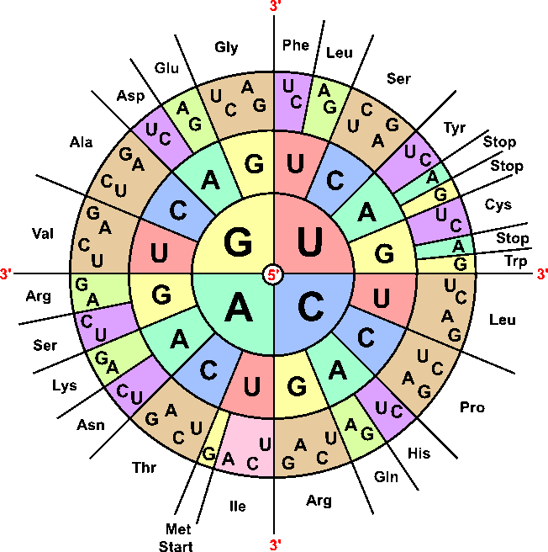
  - Cysteine bonds – use green to represent the amino acids cysteine.
- Once you have completed the table, you can begin assembling your protein.
  - Your first amino acid (methionine) is represented by a yellow bead. Add a yellow bead to the end of a pipe cleaner. Securely wrap the pipe cleaner around this yellow bead so that it cannot slip off.
  - Once you have added and secured your first yellow bead, add a cut up straw to separate this first bead from your next amino acid bead. This straw will represent the bond between amino acids.
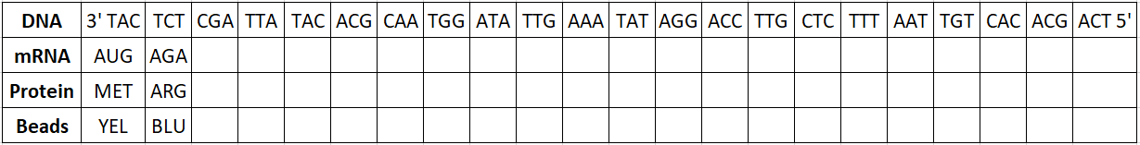
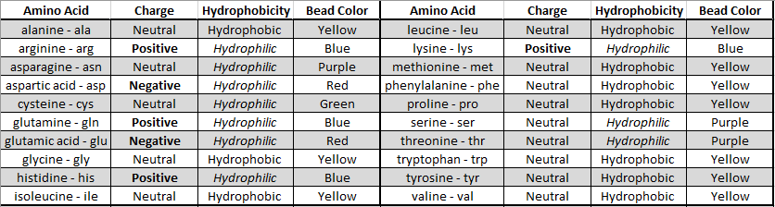
  - Add beads and cut-up straws until every amino acid in your sequence is represented. Use a second pipe cleaner if more space is needed.

- Finally, you will need to fold your protein using the guidelines below.
  - Purple hydrophilic amino acids are on the outside; yellow hydrophobic amino acids are inside.
  - Connect your opposite charges (red and blue amino acids) by wrapping them around each other.
  - Connect your green cysteine amino acids (wrap them around each other using the pipe cleaner).
- When you are finished, raise your hand. Your instructor will check your work & ask questions.
This activity was successfully completed (instructor signature)
- Submit your completed protein with your names attached to it (using masking tape or whatever your instructor provides for you) to the location that your instructor has provided.

Part 4: Review & Assessment
Overview: Rank each Driving Question in Part 2 as a 1 (completely unsure), 2 (somewhat unsure), or 3 (completely sure) based on your comprehension. Then work in teams to review each item and prepare a response. Next, write a final explanation below. You will conclude by completing a formative assessment.
How does a protein acquire its shape & function?

Part 5: Life Connections – CRISPR & Sickle Cell Anemia
Overview: For this activity, you will use a real-world case study about an individual who was cured from sickle cell anemia using CRISPR-Cas9 genetic modification.

Directions:
- Your instructor will determine which of the following resources will be used for this activity:
  - News Article: Sickle cell patient's success with gene editing raises hopes and questions - https://www.npr.org/sections/health-shots/2023/03/16/1163104822/crispr-gene-editing-sickle-cell-success-cost-ethics
  - Video: How Gene Editing Is Curing Disease https://www.youtube.com/watch?v=ezfwqmKC9Uc
- After utilizing the resources above, discuss the following questions in your assigned groups:
  - What were the main points from this resource?
  - How was CRISRP-Cas9 used to cure this disease?
  - Are there any concerns associated with this technology? Why?
  - Is this a credible source? Why or why not?
  - What is your stance? Should this technology be made more widely available? Should this approach be banned? What would you recommend and why?
- As a group, try to achieve a consensus on this issue. What is your stance, and what evidence supports your stance? Record your final ideas below. Be prepared to discuss as a class.
What is your stance on this issue?
Why is this your stance? What reasoning or evidence supports this?

Mutations & Change Unit - Packet 1 Formative Assessment
Name: Hour Date: Score: /
Directions: A 3x5 notecard with handwritten notes can be used to guide your answers. Your instructor may allow you to work in assigned groups. If so, have a different person write each response while others assist.

- What primarily determines the function of a protein? How does this relate to DNA? Include and underline the following terms: shape, function, amino acids.
Writer’s Name:
- Briefly explain & summarize how each of the following amino acid properties affect protein shape and function:
Hydrophobicity:
Positive / Negative Charge:
Cysteine Bonds:
Writer’s Name:
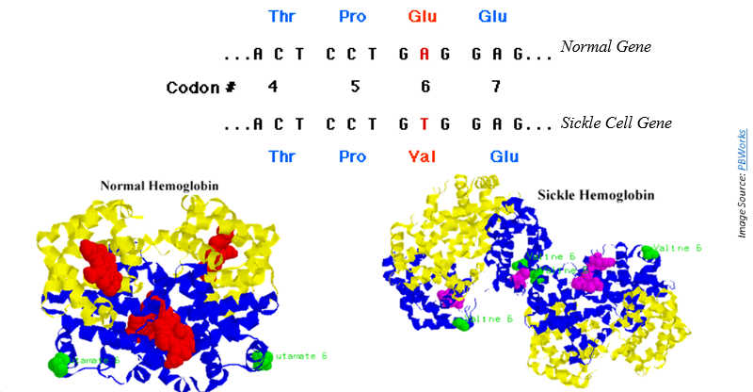
- If one letter is changed in a gene, would this affect a) transcription, b) translation, c) both, or
d) neither? Explain.
It would affect because…
- The image above shows the genes associated with normal hemoglobin proteins as well as sickle cell hemoglobin. The proteins are shown below these genes. A) How do the unaffected genes and proteins differ from the genes and proteins in individuals affected by sickle cell anemia? B) How does changing a single base affect hemoglobin proteins, red blood cells, and the entire body?
Writer’s Name:
- Sickle cell anemia occurs when a negatively-charged glutamic acid amino acid is replaced by valine (which is neutral and has no charge) in the hemoglobin protein. There are over 500 amino acids in this protein. Why would changing a single amino acid affect the entire protein? Begin by explaining how different properties of amino acids (attraction/repulsion to water, chemical charge, and cysteine bonds) determine the shape of a protein.
