Traits & Genes Unit – Packet 3
Score
□ Above & Beyond
□ Fully Complete
□ Mostly Complete
□ Incomplete – fix the following pages:
Name: Hour Date:
Date Packet is due: after Part 5 Why late?
If your work was late, describe why
Semester Schedule
Traits & Genes
Packet 1 - What determines the traits of an organism?
Packet 2 - How are traits inherited from parents?
Packet 3 – Can we predict traits?
Packet 4 - Assessment

DNA & Proteins
Packet 1: What is DNA and how does it work?
Packet 2: How does DNA affect protein assembly?
Packet 3: How does a protein acquire its shape & function?
Packet 4 - Assessment

Mutations & Change
Packet 1: How do mutations change genes & proteins?
Packet 2: How can mutations lead to new traits & species?
Packet 3: How do mutations affect natural selection?
Packet 4 - Assessment

Biodiversity & Extinctions
Packet 1: How does biodiversity affect ecosystems?
Packet 2: How and why do extinctions occur?
Packet 3: Assessment

Driving Question: Can we predict traits?

Anchoring Phenomenon: We know that offspring inherit their traits from their parents. Can we predict the traits of offspring? Can we know what traits they’ll have before they’re born? We will focus on a red and white calf born to black and white cows. How could this happen? And can we predict how likely it is to happen again?

Schedule

Part 1: Introduction
- Initial Ideas – Unexpected Red Hair
- Discussion & Developing Explanations

Part 2: Core Ideas
- Core Ideas
- Revisions of Part 1 Explanations

Part 3: Investigation
- 3A: RPS Goat Genetics
- 3B: Genetic Case Studies

Part 4: Review & Assessment
- Ranking Your Readiness
- Assessment

Part 5: Life Connections
- Packet Recap
- Life Connections – Ben’s Red Calf; Genetics & Societies

Deeper Questions
- How do different kinds of genes interact with each other, especially if one gene is dominant and another is recessive?
- How do different combinations of genes result in different traits?
- How can we use a Punnett square to predict an offspring’s traits?
- What are co-dominant, incompletely dominant, and polygenic traits?

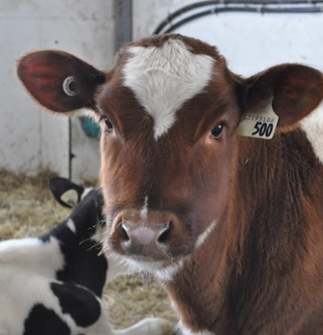
NGSS Standards: HS-LS1-4. Use a model to illustrate the role of cellular division (mitosis) and differentiation in producing and maintaining complex organisms.
HS-LS3-1 - Role of DNA/chromosomes as instructions for traits inherited from parents via meiosis
LS-LS3-3 - Predicting likelihood of different traits in a population/offspring
HS-LS1-4: How does mitosis and differentiation enable complex organisms?

Part 1: Introduction – Unexpected Red Hair
Overview: In this activity, you will begin by exploring a case study about an unexpected red calf. You will then use this story to address three claims to explain this situation. You will conclude with a class discussion to determine where you agree and disagree as a class.
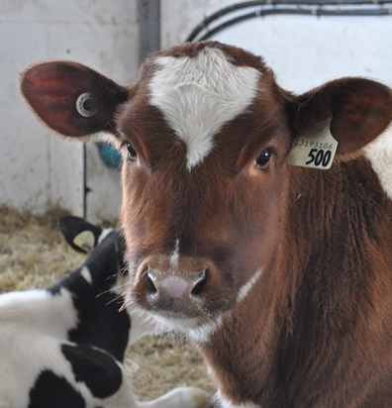
Initial Ideas: Ben grew up on a dairy farm. One day, Ben was assisting his parents as cow gave birth to a calf. Both parents of this calf were black and white. However, when the calf emerged, it had red hair! Ben was very confused; how could two black & white animals give birth to a bright red calf? How did this calf inherit a trait that was not visible in either parent? Ben was especially interested in this question because he was the only member of his family to have red hair. He wondered if maybe the same explanation applied to his situation.

Video: Next, watch the following video individually or as a class (based on your teacher’s instructions): https://www.facebook.com/watch/?v=249432969430987

- Three students shared their ideas. Do you agree or disagree with each student’s claim?
  - Ben: " I think that both parents of the calf had the genes for red hair but didn’t express them."
Agree / Disagree
  - Nina: "I think that maybe there was some interruption or change as the calf developed in the cow’s uterus, resulting in a different color." Agree / Disagree
  - Jessie: “I think that maybe the cow’s diet changed, and this changed the calf’s appearance (kind of like a flamingo).” Agree / Disagree
- Work in your small groups to discuss your ideas. How are your ideas similar or different? Decide as a group whether each statement is correct (and why). Be prepared to present your ideas to the class.

- As a class, discuss your ideas. How did you agree or disagree as a class? Record your ideas below.
We are unsure about…
We all agree that…

- Why do parents sometimes give birth to offspring with different traits? Write down your initial explanation in the space below. You will revise this explanation throughout this packet.

Part 2: Core Ideas
Overview: In this activity, you will begin with a short slideshow presentation. This will provide you with core ideas that will help you clarify your initial ideas. Your instructor will decide on how to implement this portion depending on your previous experience and capabilities with this content.
You will then work in small teams to answer the questions listed below. You should take notes in a notebook, on a dry erase board, or on scratch paper so that you are prepared to deliver your responses during the class discussion that will follow. Note: your instructor may assign specific questions to your group if time is limited.

Core Ideas Presentation: https://bit.ly/WUHS-Bio-TraitsGenesW3
Driving Questions:
- Briefly summarize Gregor Mendel’s work and his findings.
- How are traits affected by genes and proteins? How does this relate to sperm and egg cells?
- What is the difference between a dominant and a recessive gene?
- What determines whether a dominant or a recessive gene is expressed as a trait?
- What is indicated by the terms homozygous dominant, homozygous recessive, and heterozygous?
- What is an allele? What is a genotype? What is a phenotype? How are these terms related?
- True or false: a Punnett square can tell us exactly what kinds of traits that will be inherited by offspring of two parents. Explain.
- Demonstrate how to use a Punnett square to predict the traits of offspring.
- Summarize each of the following: codominant traits; incompletely dominant traits; polygenic traits.
- How is coat color in Labrador retrievers an example of how genes can sometimes affect the expression of each other?
- Revising Explanations: Return to your original explanation that you created at the end of Part 1. Based on this new information, how would you now respond to this question?
Why do parents sometimes give birth to offspring with different traits?

Part 3A Investigation: RPS Goat Genetics
Investigation Overview: In this investigation, you will be using the game Rock, Paper, Scissors to determine the genotype and phenotype for a goat for several different traits.

Directions: Complete this lab in your assigned groups of 2. Use Rock, Paper, Scissors (RPS) to determine the genotype and phenotype of your goat. The older person will be the “dominant” allele and the younger person will be the “recessive” allele. If the older person wins RPS, record that gene as dominant. If the younger person wins, record it as recessive. Play RPS twice for each trait (because an organism inherits two genes for each trait, one from each parent). Record the phenotype created by the genotype. Finally, draw your goat created by its genotype and phenotype and answer the accompanying questions.
Traits:
- Horns - Dominant: No Horns; Recessive: Horns
- Wattle (lobe of skin on the neck) - Dominant: Wattle; Recessive: No Wattle
- Hair - Dominant: Long Hair; Recessive: Short Hair
- Ears - Dominant: Long Ears; Recessive: Short Ears
- Behavior - Dominant: Nervous; Recessive: Docile (Tame)
- Markings - Dominant: Alpine; Recessive: Solid Colored
- Horns: 1st Winner: Dominant recessive 2nd Winner: Dominant recessive
Genotype: HH Hh hh Phenotype:
- Wattle: 1st Winner: Dominant recessive 2nd Winner: Dominant recessive
Genotype: WW Ww ww Phenotype:
- Hair: 1st Winner: Dominant recessive 2nd Winner: Dominant recessive
Genotype: LL Ll ll Phenotype:
- Ears: 1st Winner: Dominant recessive 2nd Winner: Dominant recessive
Genotype: EE Ee ee Phenotype:
- Behavior: 1st Winner: Dominant recessive 2nd Winner: Dominant recessive
Genotype: BB Bb bb Phenotype:
- Markings: 1st Winner: Dominant recessive 2nd Winner: Dominant recessive
Genotype: MM Mm mm Phenotype:
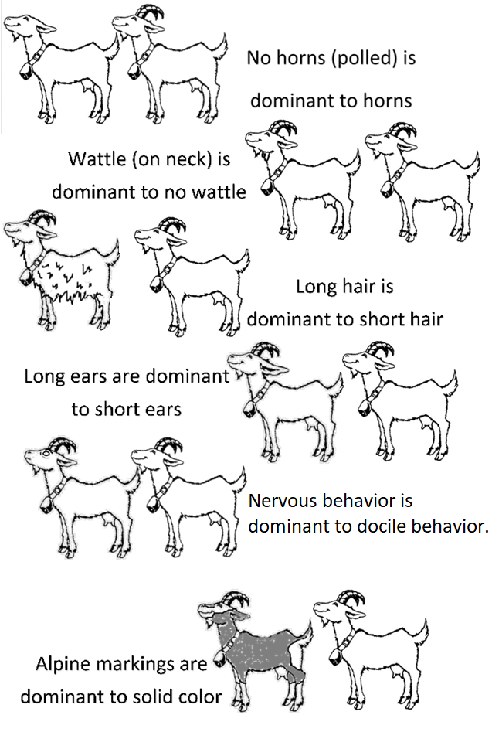

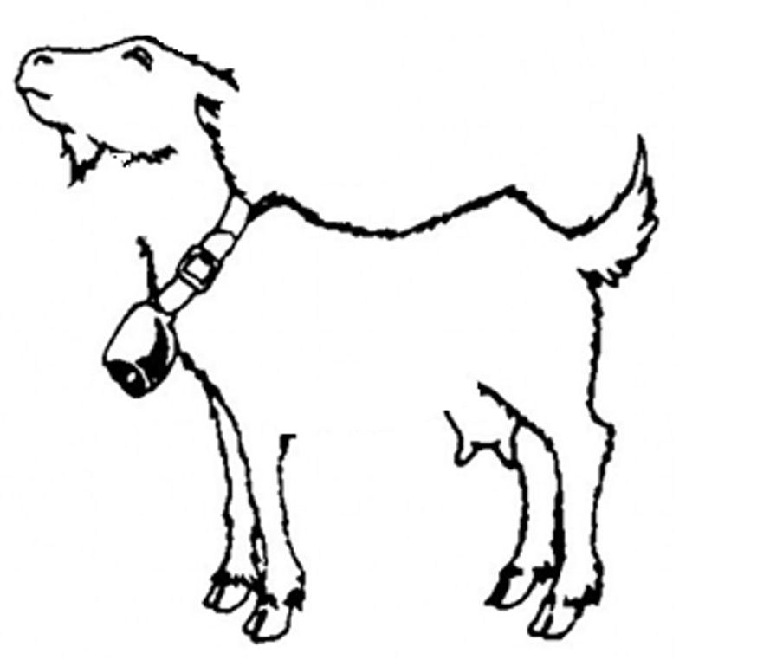
- Draw your goat below.

- Next, choose another person’s goat to mate with. List the genotypes and phenotypes for the mate for your goat below for all six traits:
Horns - Phenotype Genotype
Wattle - Phenotype Genotype
Hair - Phenotype Genotype
Ears - Phenotype Genotype
Behavior - Phenotype Genotype
Markings - Phenotype Genotype
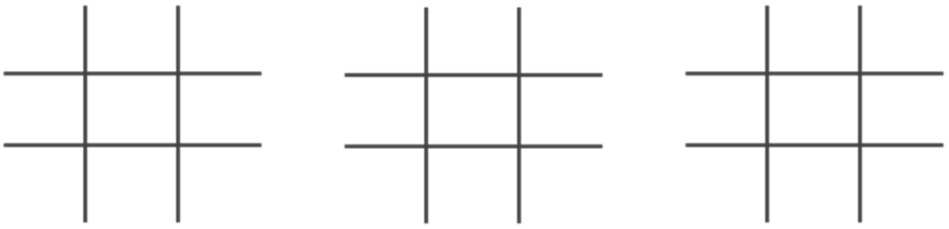
- In the space below, do a Punnett Square for the three traits of your choosing. Use the genotype of your goat and the genotype of the mate of your goat (a goat from another group).
- In the space below, describe the most likely traits of your offspring based on the prior Punnett squares.
When you think you are finished, raise your hand and be prepared to explain your work to your instructor.
This activity was successfully completed (instructor signature)

Part 3B Investigation: Genetics Case Studies

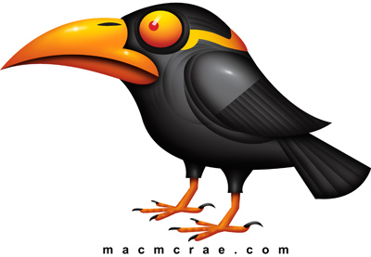
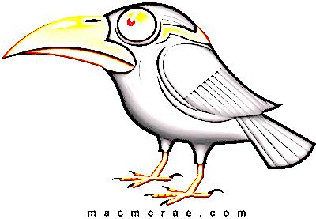
- A male and female bird has 4 unhatched eggs. The lighter female
on the left is heterozygous; the darker male on the right is
homozygous recessive. Use B and/or b for your genotypes.
Images by Mac McRae
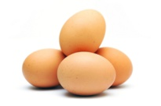
  - Write the genotype of the parents below:
Female: Male:
  - Which color is dominant, gray or black? How do you know?
Gray / Black, because…
^{Circle one}
  - Write the phenotype of the female and the phenotype of the male below:
Female: Male:
  - Complete the Punnett Square below for this couple
  - What are the odds the offspring will be gray? Circle one.
0% (0/4) 25% (1/4) 50% (2/4) 75% (3/4) 100% (4/4)
What are the odds the offspring will be black? Circle one.
0% (0/4) 25% (1/4) 50% (2/4) 75% (3/4) 100% (4/4)

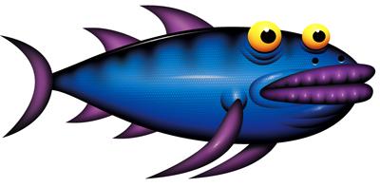
- A family of fish is shown here. Double fins
are dominant; a single fin is recessive.
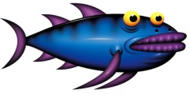
  - Based on their phenotypes, circle the
genotypes that are possible for the adult fish.
AA Aa aa
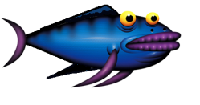
  - How many baby fish have the dominant phenotype?
____ / 8
  - How many have the recessive phenotype?
____ / 8
  - Complete Punnett squares for all possible genotype combinations of the larger adult fish. Circle the Punnett square that aligns most closely to the ratios of these offspring.
  - Based on the offspring, what are the genotypes of the parents? &
- Back fins are dominant on this species of salamander. Could this couple have had this baby? Explain.
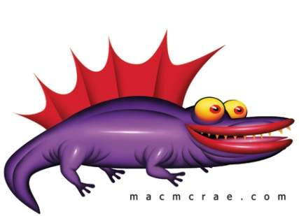

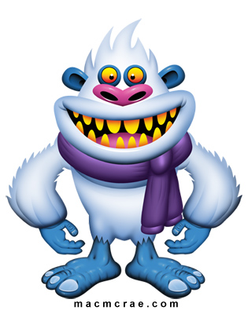
- Two yetis have four babies
Images by Mac McRae
  - What is the dominant phenotype?
  - What is the recessive phenotype?
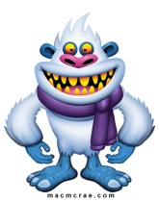
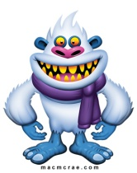
  - Create two Punnett squares that could be possible
based on the phenotypes of the parents. Circle
the P-square is most likely based on these offspring.

Part 4: Review & Assessment
Overview: Rank each Driving Question in Part 2 as a 1 (completely unsure), 2 (somewhat unsure), or 3 (completely sure) based on your comprehension. Then work in teams to review each item and prepare a response. Next, write a final explanation below. You will conclude by completing a formative assessment.
Why do parents sometimes give birth to offspring with different traits?

Part 5A: Life Connections – Ben’s Red Calf
Initial Ideas: Ben was feeding a newborn calf as a neighbor stopped by. Ben excitedly explained that this red & white calf came from parents who were both black & white animals. The neighbor scoffed and suggested that Ben’s parents should sell this calf. “Those red ones are terrible,” he said, adding, “They are terrible at producing milk, they will kick you, and they will try to break down your fences all the time.” Ben was unsure if someone could know this just by looking at an animal’s color. When Ben asked his parents, they laughed and said the idea was ridiculous. They argued the proteins for hair color had no impact on whether or not this animal would be productive, friendly, or safe. They suggested the neighbor simply held a grudge from a previous bad experience with a red calf.

- Three students shared their ideas. Do you agree or disagree with each student’s claim?
  - Ben: "I think my parents are correct. Hair color is totally different from those other traits."
Agree / Disagree
  - Nina: "I think that maybe the neighbor might be correct. Maybe the hair color determines all those other traits, or is somehow linked to them(?)" Agree / Disagree
  - Jessie: “I am pretty sure that an animal’s productivity, temperament, and other traits are affected by lots of factors, including non-genetic factors like diet and upbringing.” Agree / Disagree
- Work in your small groups to discuss your ideas. How are your ideas similar or different? Decide as a group whether each statement is correct (and why). Be prepared to present your ideas to the class.

- As a class, discuss your ideas. How did you agree or disagree as a class? Record your ideas below.
We all agree that…
We are unsure about…

Part 5B: Life Connections – Genetics & Societies
Overview: Prejudice occurs when an individual inaccurately makes assumptions about a group of people based on particular traits. It is impossible to predict a person’s character based on a random selection of features.
Prejudice remains common despite being scientifically disproven. While some genes for traits are linked, a person’s character is not determined by an individual gene. Furthermore, a person’s character cannot be predicted by the presence or absence of another trait. As such, it is impossible to know everything about a person simply by looking at their physical appearance.

Human behaviors are determined by a wide array of factors that are both genetic and environmental. A person’s environment (e.g., home, schooling, community, etc.) generally affects character far more than genetic factors. Additionally, all human beings are 99.9% identical in their genetic makeup. Humans as a species are far more genetically similar than they are different. As such, it is both inaccurate and illogical to make assumptions about an entire group of people based on an arbitrary selection of a few physical traits.

However, prejudice remains widespread throughout the world. In this activity, you will use an internet search engine to explore how prejudice occurs in different cultures and across different contexts.

Directions: As a group, use a computer, laptop, or personal device (if ok’d by your instructor) to look up
information for different types of prejudice below. Each option below is hyperlinked to provide you with information to get you started. If necessary, use an internet search engine to find additional information on this topic. Your instructor will determine how topics will be assigned. Be prepared to summarize your findings for your group and/or the rest of the class. You also need to take time as a group to address the questions below.

After summarizing these scenarios, you summarize any similarities or patterns that you might have observed that are common to most or all of the examples provided. Note: internet searches on some of these topics may result in graphic content. Speak with your instructor if you have particular concerns about a topic.

Examples of Prejudice in Different Cultures
- Japan: Blood Type Harassment (“it-bura-hara”) (Source: BBC)
- Rwanda: Genocide Against the Tutsi (Source: Montreal Holocaust Museum)
- Germany: Nazis and Racism (Source: US Holocaust Memorial Museum)
- United States: “Red Lining” & Racial Discrimination (Source: NPR)
- US & Europe: Phrenology: The Pseudoscience of Skull Shapes (Source: Medical News Today)
- United States: Japanese-American Internment (Source: USHistory.org)
Questions to Address
- In what way does each example pertain to the definition of prejudice (inaccurately making assumptions about a group of people based on a particular trait)?
- What damage results or resulted from this form of prejudice? How can this harm a society or culture?
- Has this problem been resolved, or are there ramifications that are still occurring today?
- How would you describe your personal roles and obligations in addressing prejudice?

Traits & Genes Unit - Packet 3 Formative Assessment
Name: Hour Date: Score: /
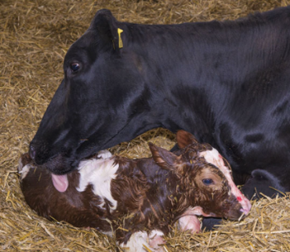
Directions: A 3x5 notecard with handwritten notes can be used to guide your answers. If allowed to work in pairs or groups, rotate who writes for each question.

- A cow and bull that are both black and white gave birth to a red & white calf. How could this happen? Include and underline the terms dominant genes, recessive genes, heterozygous, and homozygous recessive. Note: black and white is the dominant trait in dairy cows; red and white is recessive.
Writer’s Name:
- Use the information from the previous question to answer the questions below. Phenotype refers to the color of each animal. For the genotypes, use “B” and/or “b”.
What was the phenotype of the calf’s mother? What was her genotype?
What was the phenotype of the calf’s father? What was his genotype?
What was the phenotype of the calf? What was her genotype?
What is the difference between genotype and phenotype?
Writer’s Name:
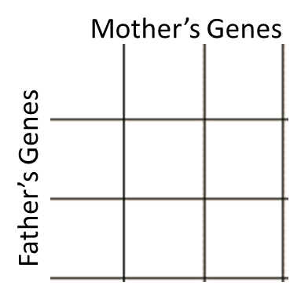
- In the space below, complete a Punnett square using the genotypes of the parents above. Then summarize what this indicates about how two black & white cows could have a red & white calf.
Writer’s Name:
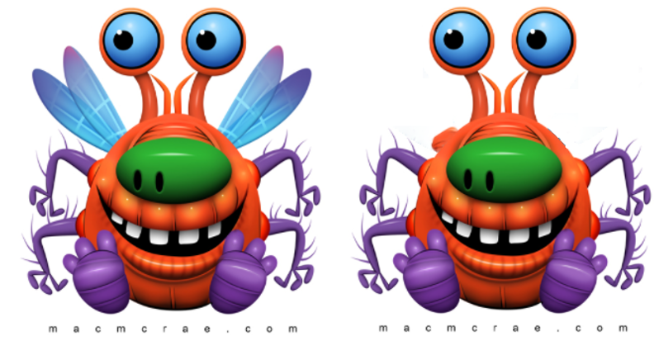
- Two bugs mate. One has wings; the other does not. The bug with wings is homozygous dominant. The bug without wings is homozygous recessive. Use “winged” or “wingless” for phenotypes. Use B and/or b for genotypes.
Phenotype of the left bug:
Genotype of the left bug
Phenotype of the right bug:
Genotype of the left bug:
Complete a Punnett square for the offspring of this pair
Based on this Punnett square, what are the possible genotypes and phenotypes for the offspring of this pair?
Writer’s Name:
Images by Mac McRae
- The resulting offspring of a red and a white flower are pink. This suggests that this trait is
  - Dominant/Recessive b. Co-dominant c. Incompletely Dominant d. Polygenic
Explain why you chose this answer.
Writer’s Name:
- A black fish mates with a yellow fish, creating offspring are black & yellow. This trait is…
  - Dominant/Recessive b. Co-dominant c. Incompletely Dominant d. Polygenic
Explain why you chose this answer.
Writer’s Name:
- Height in humans is determined by six different genes. This suggests that this trait is
  - Dominant/Recessive b. Co-dominant c. Incompletely Dominant d. Polygenic
Explain why you chose this answer.
Writer’s Name:

